

**KAUNAS UNIVERSITY OF TECHNOLOGY**

**FACULTY OF INFORMATICS**

**T120B166 Development of Computer Games and Interactive Applications**

*“DE_RUDE_2X2”*

*Regijus Borodinas IFF-6/11*

*Marius Teleiša IFF-6/11*

*Jurgis Petrauskas IFF-6/11*

*Benas Bernadišius IFF-6/11*

*Tomas Volkevičius IFF-6/11*

Date: *2019.03.04*

Kaunas, 2019

Table of contents

Table of Figures 3

Table of Tables/Functions 8

Work Distribution Table 9

Description of Your Game 9

Laboratory Work #1 10

List of Tasks 10

Solution 10

Marius Teleiša 10

Regijus Borodinas 27

Tomas Volkevičius 47

Jurgis Petrauskas 64

Benas Bernadišius 90

Laboratory Work #2 98

List of Tasks 98

Solution 99

Regijus Borodinas 99

Literature List 123

ANNEX 126

# Table of Figures

Figure 1 part of the map that Marius Teleiša worked on mostly 11

Figure 2 second floor of the Labyrinth zone 12

Figure 3 First floor of the Labyrinth zone 13

Figure 4 hierarchy of the Labyrinth zone part 1 14

Figure 5 hierarchy of the Labyrinth zone part 2 14

Figure 6 all light emitting objects in the Labyrinth zone 15

Figure 7 light 1 and 2 16

Figure 8 light 3 16

Figure 9 light 4 17

Figure 10 light 5 17

Figure 11 light 6 18

Figure 12 light 7 18

Figure 13 light 8 19

Figure 14 light 9 19

Figure 15 light 10 20

Figure 16 light 11 20

Figure 17 sound 1 21

Figure 18 sound 2 21

Figure 19 sound 3 22

Figure 20 sound 4 22

Figure 21 sound 5 23

Figure 22 sound 6 23

Figure 23 sound 7 24

Figure 24 sound 8 24

Figure 25 sound 9 25

Figure 26 sound 10 25

Figure 27 hierarchy with materials 26

Figure 28 final defense result 27

Figure 29 player entered the pyramid area and the event prints to console 27

Figure 30 Regijus’ terrain 28

Figure 31 Stronghold 28

Figure 32 Stronghold interior 29

Figure 33 Pyramid 29

Figure 34 Store 30

Figure 35 House 30

Figure 36 City Wall 31

Figure 37 Rocky Household 31

Figure 38 Arena 32

Figure 39 Stage 32

Figure 40 Beach House 33

Figure 41 Beach House Interior 33

Figure 42 Reward Maze 33

Figure 43 Regijus’ lighting sources 34

Figure 44 Stronghold lighting source 35

Figure 45 Stronghold interior lighting source 35

Figure 46 Reward labyrinth Interior lighting source 36

Figure 47 Reward labyrinth lighting source 36

Figure 48 Beach house lighting source 37

Figure 49 Rocky household lighting source 37

Figure 50 City entrance lighting source 38

Figure 51 Store lighting source 38

Figure 52 Arena lighting source 39

Figure 53 Pyramid lighting source 39

Figure 54 Gunshot sounds 40

Figure 55 Sound effects 40

Figure 56 Theme music 40

Figure 57 Wind audio settings 41

Figure 58 Stadium audio settings 41

Figure 59 Swords clashing audio settings 42

Figure 60 Alien spaceship theme audio settings 42

Figure 61 9mm audio settings 43

Figure 62 600 Nitro audio settings 43

Figure 63 Gun fight audio settings 44

Figure 64 M1 Garand Gun audio settings 44

Figure 65 Ricochet of a bullet audio settings 45

Figure 66 Shotgun audio settings 45

Figure 67 Sound locations 46

Figure 68 Sound locations 46

Figure 69 Regijus’ materials 47

Figure 70 Defense task’s light location 47

Figure 71 Defense task’s lighting source settings 47

Figure 72 Tomas's plane 48

Figure 73 Sample asset added 48

Figure 74 Objects of the asset 49

Figure 75 Sample asset added 49

Figure 76 List of objects in the asset part 1 49

Figure 77 List of objects in the asset part 2 50

Figure 78 Sample asset added 50

Figure 79 11 assets which have not been used yet (marked) 51

Figure 80 Sample asset added 51

Figure 81 Objects of the asset 51

Figure 82 Light on the castle 52

Figure 83 Options of lightning 52

Figure 84 Options of lightning 53

Figure 85 Options of lightning 53

Figure 86 Light on the house 54

Figure 87 Options of lightning 54

Figure 88 Options of lightning 55

Figure 89 Lightning in the tent 55

Figure 90 Options of the lightning 56

Figure 91 Options of the lightning 56

Figure 92 Options of the lightning 56

Figure 93 Options of the lightning 57

Figure 94 Lightning over the gates with lightning options on the side 57

Figure 95 Audio sounds used 57

Figure 96 Audio options (applause) 58

Figure 97 Audio options (dragon sounds) 58

Figure 98 Audio options (creepy background) 59

Figure 99 Audio options (background sounds) 59

Figure 100 Audio options (rain sounds) 60

Figure 101 Audio options (fire bow sounds) 60

Figure 102 Audio options (heartbeat sounds) 61

Figure 103 Audio options (explosions sounds) 61

Figure 104 Audio options (hammering sounds) 62

Figure 105 Audio options (punch sounds) 62

Figure 106 Example of audio locations 1 63

Figure 107 Example of audio locations 2 63

Figure 108 Example of audio locations 3 63

Figure 109 materials added / used 64

Figure 110 Result of defense task 64

Figure 111 Map 65

Figure 112 Treasure Chest 65

Figure 113 Sand house 66

Figure 114 Desert well 66

Figure 115 Hierarchy of assets 67

Figure 116 Lightning above boxing ring 68

Figure 117 Spotlight properties 69

Figure 118 Spotligh 69

Figure 119 Spotlight hierarchy 70

Figure 120 Directional Light 71

Figure 121 Directional Light(1) 72

Figure 122 Directional Light(2) 73

Figure 123 Spot Light 74

Figure 124 Directional Light(3) 75

Figure 125 Directional Light (4) 76

Figure 126 Spot Light(!) 77

Figure 127 Directional Light (5) 78

Figure 128 SpotLight 79

Figure 129 SpotLight(1) 80

Figure 130 Sounds 80

Figure 131 Audio of boxing area 81

Figure 132 Sound of Sand house 81

Figure 133 Sound of flag 82

Figure 134 Sound of a flag 83

Figure 135 Sound of a flag 84

Figure 136 Sound of a flag 85

Figure 137 Sound of a flag 86

Figure 138 Sound of a flag 87

Figure 139 Sound of a flag 88

Figure 140 Sound of arch 89

Figure 141 selected materials 89

Figure 142 materials created 90

Figure 143 Defence task. Properties of audio and its visualisation 90

Figure 144 35 of the visible custom assets were created by me. 92

Figure 145 example asset "arabic tent" 92

Figure 146 Light 1 93

Figure 147 Light 2 94

Figure 148 Light 3 94

Figure 149 Light 4 95

Figure 150 Light 5 95

Figure 151 Light 6 96

Figure 152 Light 7 96

Figure 153 Light 8 97

Figure 154 Light 9 97

Figure 155 Imported audio files 98

Figure 156 Used audio files 98

Figure 157 Custom-made materials 98

Figure 158 Regijus’ terrain 100

Figure 159 Regijus’ terrain layers 100

Figure 160 Regijus’ trees 101

Figure 161 Regijus’ trees in hierarchy 101

Figure 162 Tree materials and textures 101

Figure 163 Example of tree hierarchy 102

Figure 164 Example of tree hierarchy 102

Figure 165 Model rigging 103

Figure 166 Model bone system 103

Figure 167 Model in game 103

Figure 168 Regijus’ animations 104

Figure 169 Animation 1 104

Figure 170 Animation 2 104

Figure 171 Animation 3 104

Figure 172 Animation 4 105

Figure 173 Animation 5 105

Figure 174 Animation 6 105

Figure 175 Animation 7 105

Figure 176 Regijus’ effects 105

Figure 177 Effect 1 – Portal 106

Figure 178 Effect 2 – Amber rain over the arena 106

Figure 179 Effect 3 – Small chimney smoke 106

Figure 180 Effect 4 - Huge dark smoke from stronghold 107

Figure 181 Effect 5 – Pyramid particle effect 107

Figure 182 Regijus’ skybox textures and materials 107

Figure 183 Regijus’ skybox 108

Figure 184 Regijus’ physics materials 108

Figure 185 Physics material example 108

Figure 186 Another physics material example 108

Figure 187 Example of applied physics material on object 109

Figure 188 Stronghold collider 109

Figure 189 Papaya trees colliders 109

Figure 190 Rocks colliders 110

Figure 191 Boxes colliders 110

Figure 192 Tyres and jerry cans colliders 110

Figure 193 City wall colliders 111

Figure 194 Simple house colliders 111

Figure 195 Anubis statues colliders 111

Figure 196 Store and cacti colliders 112

Figure 197 Beach house colliders 112

Figure 198 Table dropdown animation 113

Figure 199 Barrell blow up animation 113

Figure 200 Maze door dropdown animation 113

Figure 201 Disappear animation 114

Figure 202 Move up animation 114

Figure 203 Regijus’ physics scripts 114

Figure 204 Regijus’ initial benchmark 115

Figure 205 Regijus’ performance test 115

Figure 206 Regijus’ benchmark after setting static 115

Figure 207 Regijus’ performance test after setting static 116

Figure 208 Regijus’ benchmark after setting deferred rendering 116

Figure 209 Regijus’ performance test after setting deferred rendering 116

Figure 210 Regijus’ benchmark after setting forward rendering 117

Figure 211 Regijus’ performance test after setting forward rendering 117

Figure 212 Regijus’ lighting settings 117

Figure 213 Regijus’ example of baked light 118

Figure 214 Regijus’ benchmark after setting baked lights 118

Figure 215 Regijus’ performance test after setting baked lights 118

Figure 216 Regijus’ optimized texture 1 119

Figure 217 Regijus’ optimized texture 2 119

Figure 218 Regijus’ optimized texture 3 120

Figure 219 Regijus’ optimized texture 4 120

Figure 220 Regijus optimized texture 5 121

Figure 221 Regijus’ benchmark after optimizing textures 121

Figure 222 Regijus’ performance test after optimizing textures. 122

Figure 223 Regijus’ benchmark after applying soft shadows 122

Figure 224 Regijus’ performance test after applying soft shadows 123

Figure 225 Regijus’ benchmark after applying hard shadows 123

Figure 226 Regijus’ performance test after applying hard shadows 123

# Table of Tables/Functions

1 Table. Work Distribution Table 6

# Work Distribution Table

|  |  |
| --- | --- |
| **Name** | **Responsible for** |
| Regijus Borodinas | World design, physics, mechanics etc |
| Benas Bernadišius | World design, physics, mechanics etc |
| Marius Teleiša | Player movement, graphical effects, enemy/weapon creation |
| Jurgis Petrauskas | Terrain and buildings creation/improvements, physics |
| Tomas Volkevičius | Gameplay development, environment design |

1 Table. Work Distribution Table

# Description of Your Game

1. **3D or 2D?** 3D
2. **What type is your game?** First Person Shooter (FPS)
3. **What genre is your game?** Action-Adventure
4. **Platforms?** PC
5. **Scenario Description.** „De_Rude_2x2” is an open world first person shooter game set in a desert environment. The map has a „gladiator arena“ which is surrounded by a city, an abandoned fortress, a labyrinth and other structures. There are various zones which contain entities that are hostile towards the player. These zones have different conditions for clearing them and contain various enemies, environmental hazards, and puzzles that make that task more difficult. Zones also contain pickups that help the player by restoring his health, ammo, or boosting movement speed. The player can get access to different weapons, zones and upgrades by progressing through the game. The goal of the game is to clear all the zones and to become the strongest character in the desert.

# Laboratory Work #1

## List of Tasks

1. Create a map in at least 10x10 scenario elements
2. Choose your Style. Add at least 50 environmental elements
3. Add lighting sources (at least 10 units, with different settings, such as: color, intensity, etc.)
4. Complement the map with sound (at least 10 different sounds and at least 5 pieces of background music in different locations)
5. Use at least 20 different materials (excluding asset store content)

## Solution

### Marius Teleiša

#### Create a map in at least 10x10 scenario elements

We used “Terrain” objects from standard assets as our ground, but they are quite large (250x250). 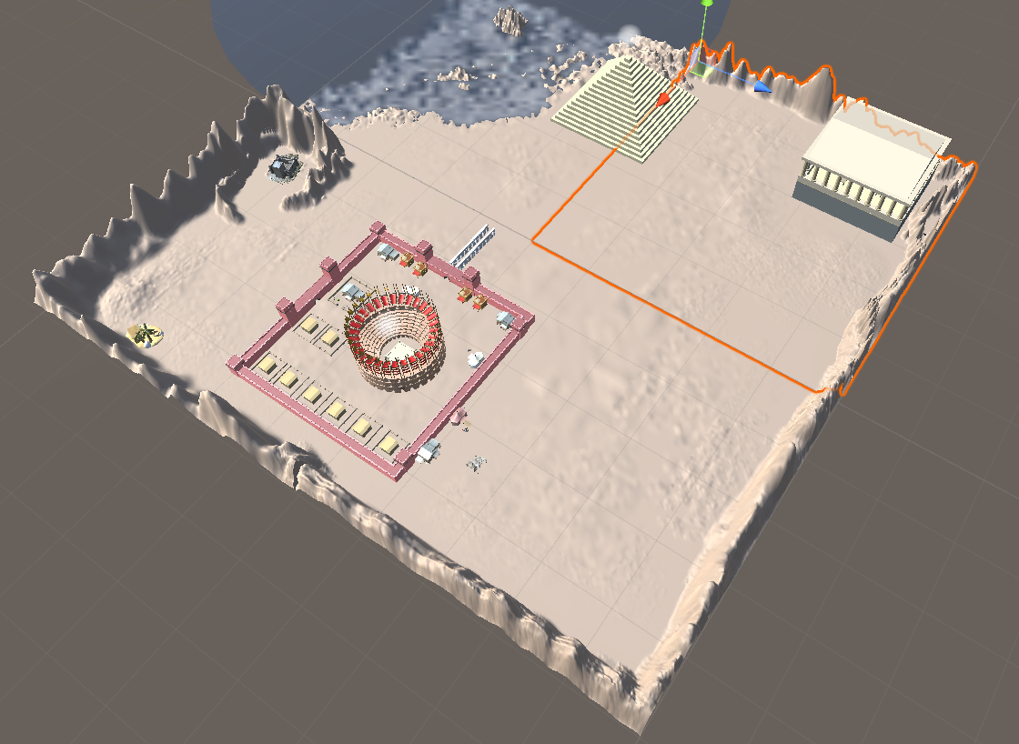

Figure 1 part of the map that Marius Teleiša worked on mostly

#### Add at least 50 environmental elements

Most of the objects were created either using probuilder or standard unity assets (eg. Cubes).

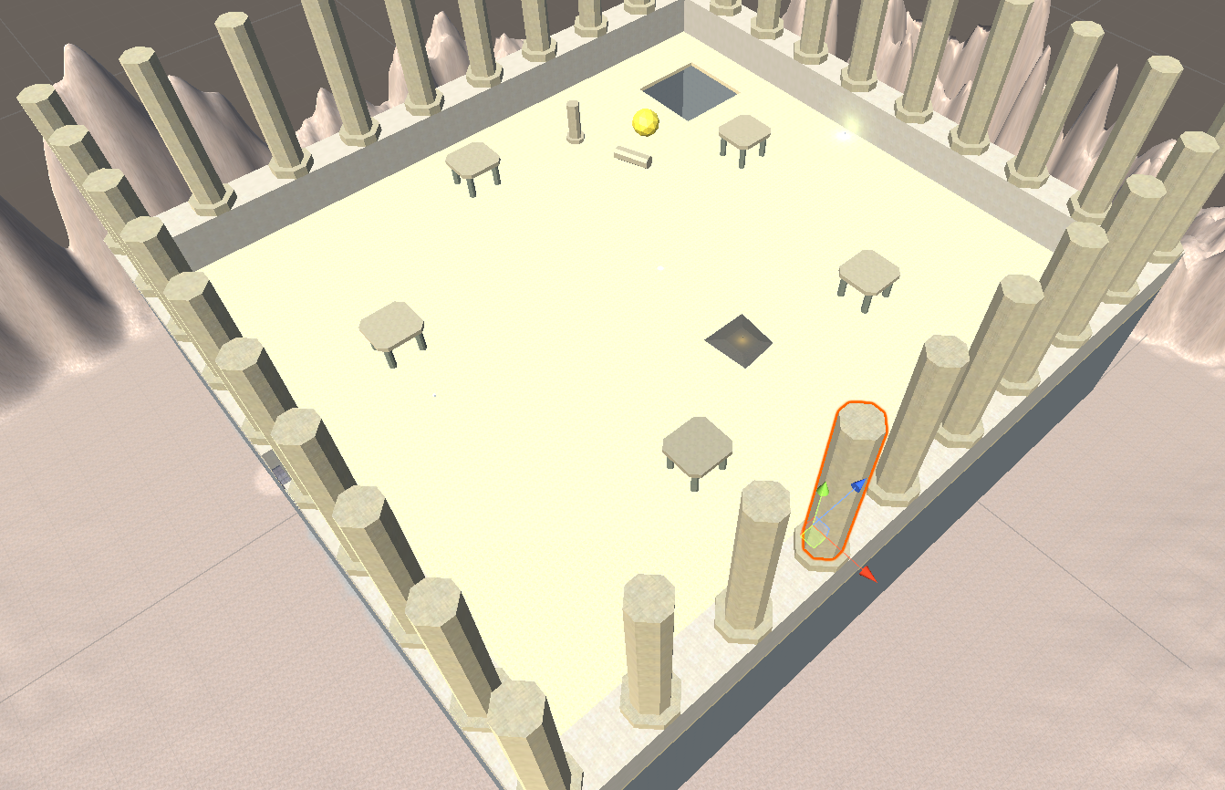

Figure 2 second floor of the Labyrinth zone

Columns, rubble patch, and structures that look like tables in figure 2 were created using ProBuilder from the Unity AssetStore.

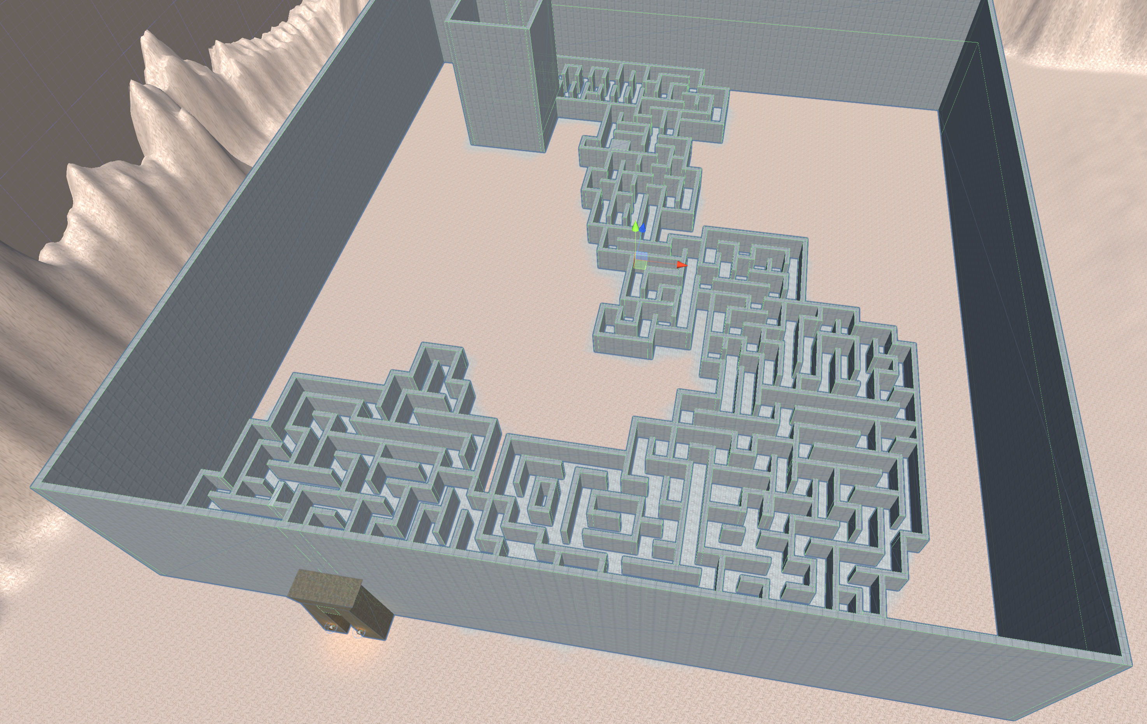

Figure 3 First floor of the Labyrinth zone

In *Figure 3* the maze and walls are made from standard Unity cubes.

|  |  |
| --- | --- |
| Figure 4 hierarchy of the Labyrinth zone part 1 | Figure 5 hierarchy of the Labyrinth zone part 2 |

*Figure 4* displays part of the hierarchy of the “Labyrinth_zone”. The maze is comprised of many differently sized cubes that were each resized and placed by hand.

#### Add lighting sources (at least 10 units, with different settings, such as: color, intensity, etc.)

*figure 6* shows 13 light sources used in the Labyrinth zone and about 10 of them have different settings.

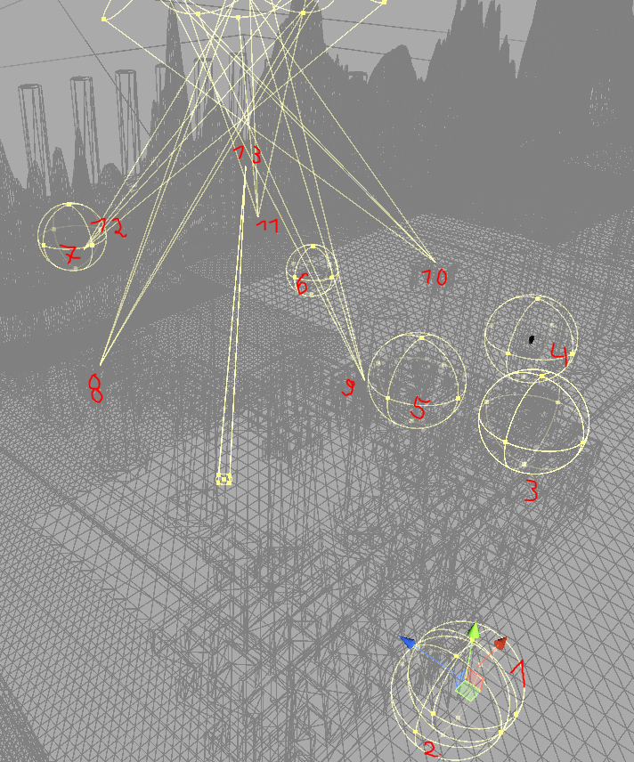

Figure 6 all light emitting objects in the Labyrinth zone

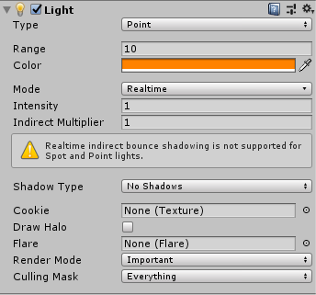

Figure 7 light 1 and 2

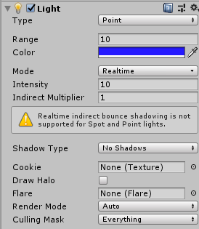

Figure 8 light 3

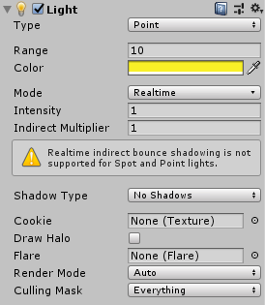

Figure 9 light 4

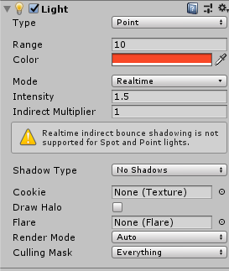

Figure 10 light 5

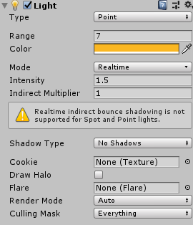

Figure 11 light 6

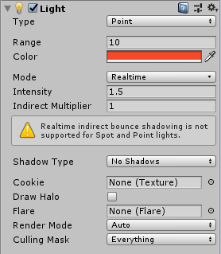

Figure 12 light 7

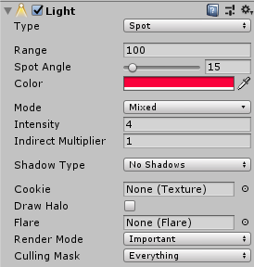

Figure 13 light 8

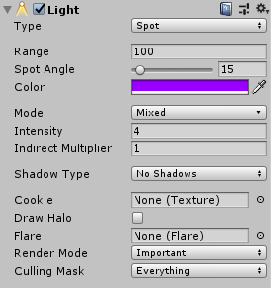

Figure 14 light 9

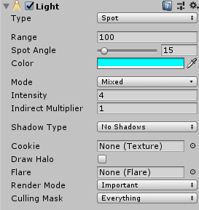

Figure 15 light 10

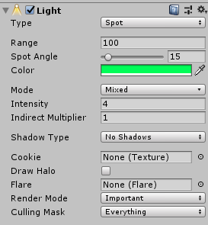

Figure 16 light 11

#### Complement the map with sound (at least 10 different sounds and at least 5 pieces of background music in different locations)

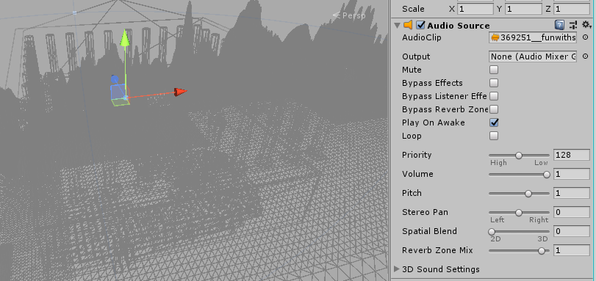

Figure 17 sound 1

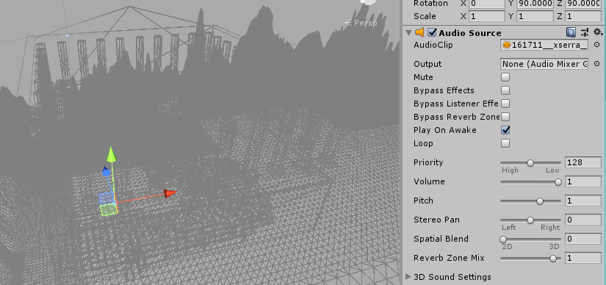

Figure 18 sound 2

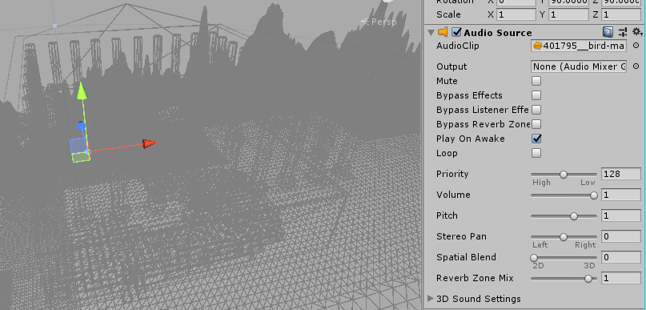

Figure 19 sound 3

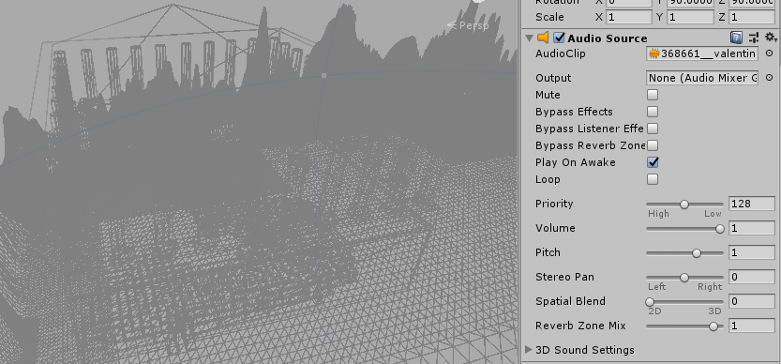

Figure 20 sound 4

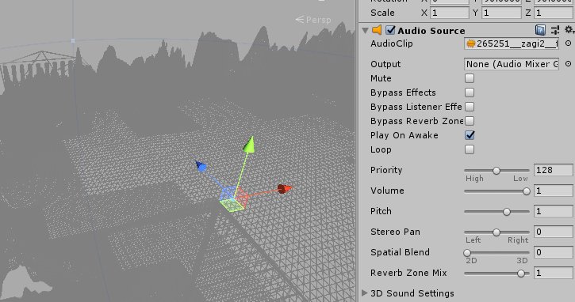

Figure 21 sound 5

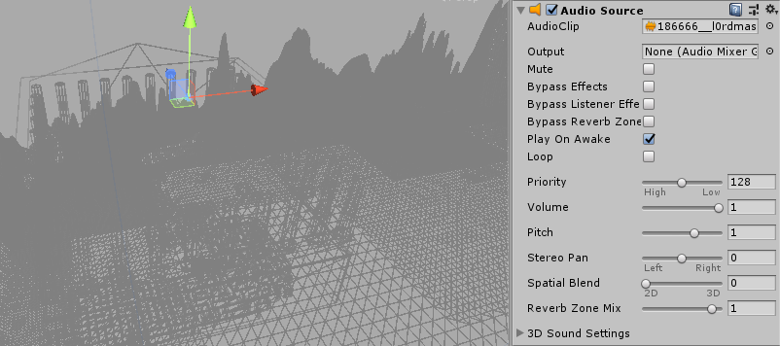

Figure 22 sound 6

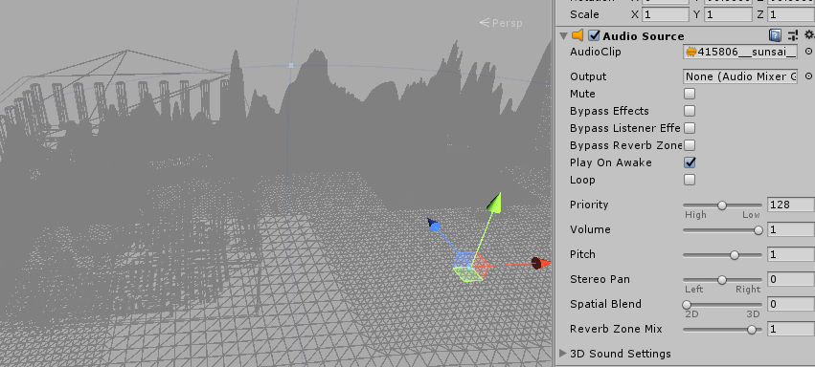

Figure 23 sound 7

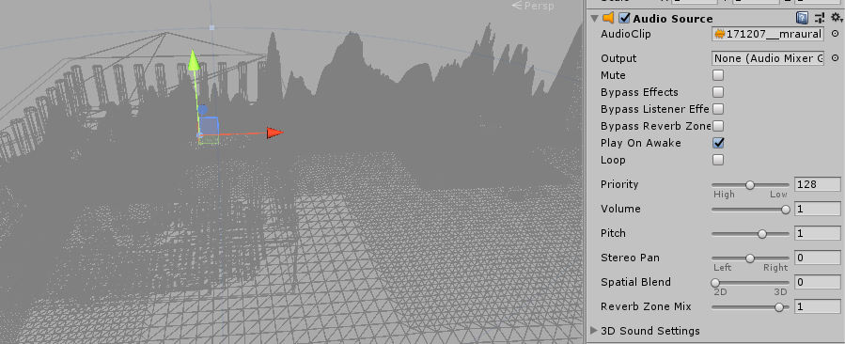

Figure 24 sound 8

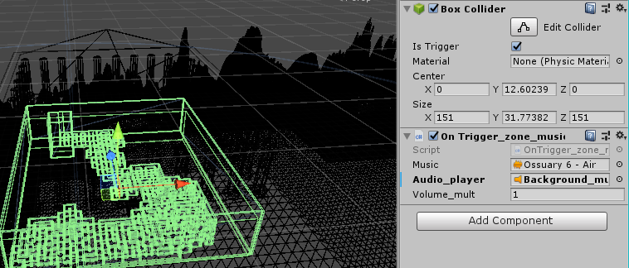

Figure 25 sound 9

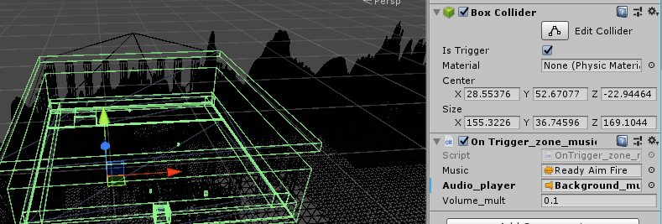

Figure 26 sound 10

#### Use at least 20 different materials (excluding asset store content)

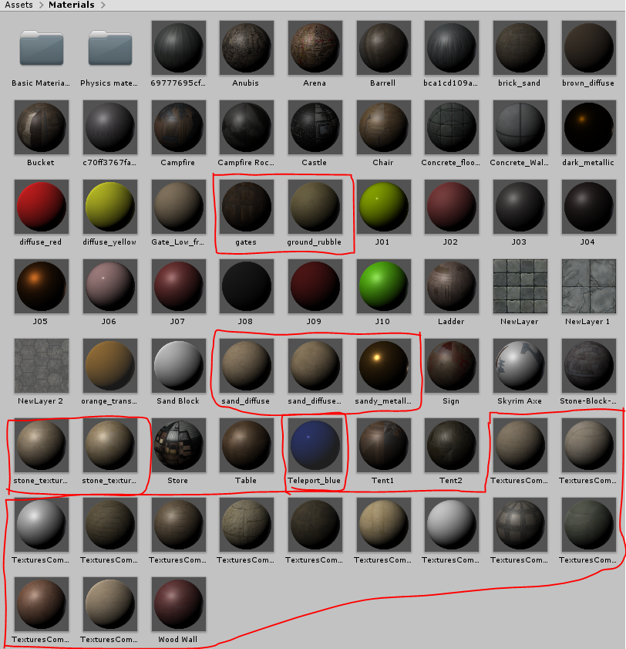

Figure 27 hierarchy with materials

#### Defense task

Entering the area of the pyramid should start playing some music.

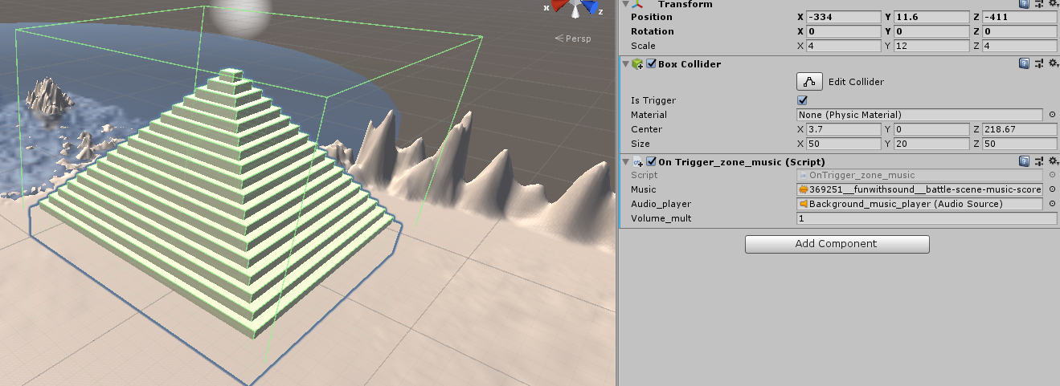

Figure 28 final defense result

A collider trigger and a script was added to the pyramid. The script waits for player to enter the trigger with *OnTriggerEnter* function. The script stops current playing track, assigns *Music, Volume_mult*  to *Audio_player­* and then plays the assigned clip and outputs a message to the console. In *figure 29* we can see that the player has entered the pyramid area and the console message saying “player has entered the labyrinth” (it says “labyrinth” because the script was originally used in the labyrinth zone), which means that the player has entered the trigger.

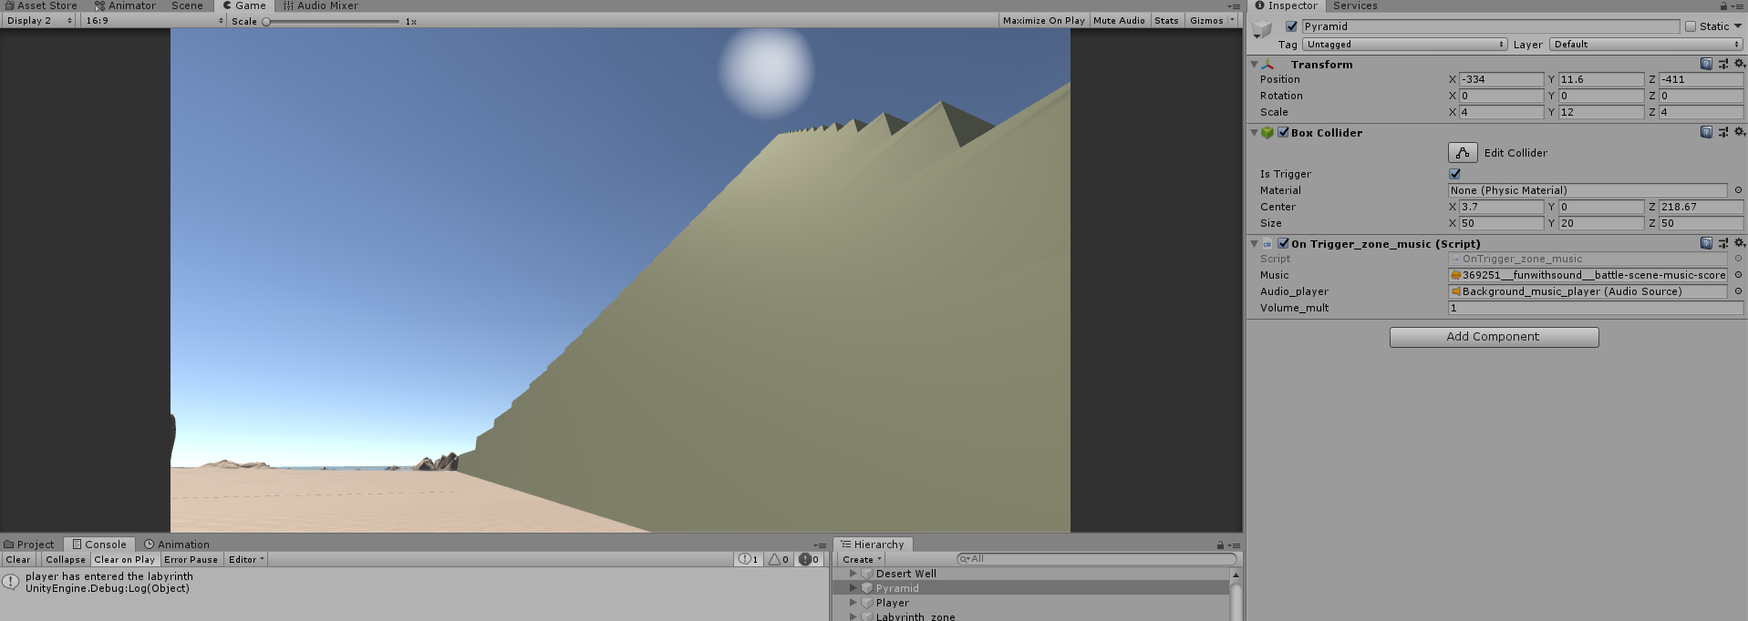

Figure 29 player entered the pyramid area and the event prints to console

### Regijus Borodinas

#### Create a map in at least 10x10 scenario elements.

I’ve added mountains to the terrain and built many different areas. We’ve split our map building tasks but this is the terrain in which I’ve had the most of my builds.

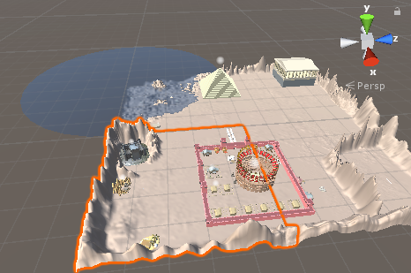

Figure 30 Regijus’ terrain

#### Choose your Style. Add at least 50 environmental elements.

Stronghold, which contains around 11 different elements.

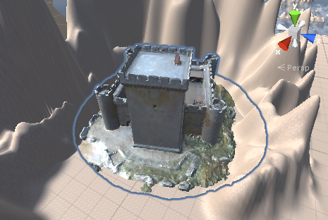

Figure 31 Stronghold

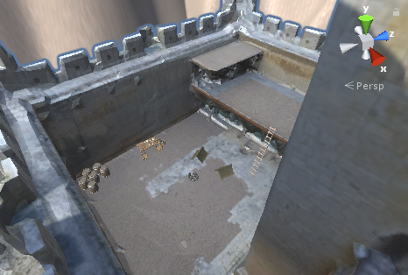

Figure 32 Stronghold interior

Pyramid contains 18 different cube blocks.

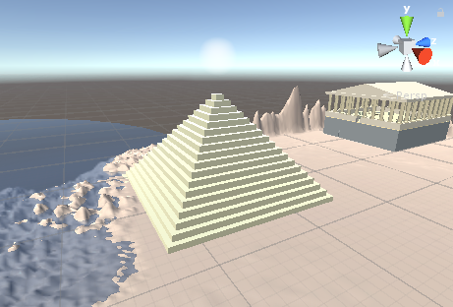

Figure 33 Pyramid

Store contains 8 different elements.

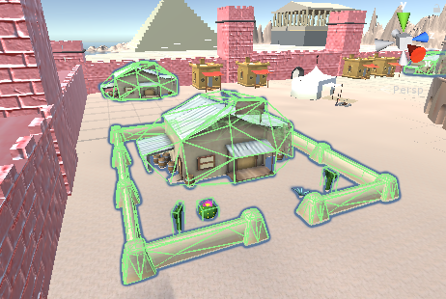

Figure 34 Store

House contains 9 different elements.

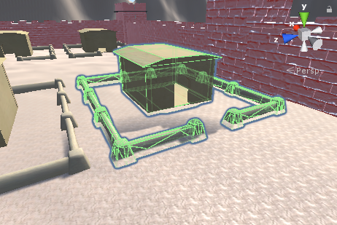

Figure 35 House

City wall contains around 12 different elements.

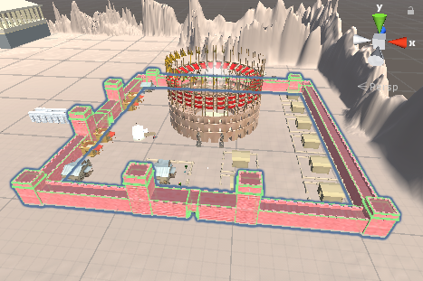

Figure 36 City Wall

Rocky household contains around 18 different elements.

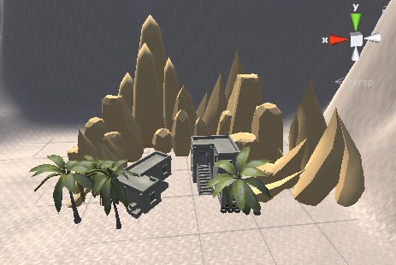

Figure 37 Rocky Household

Arena contains 6 different elements.

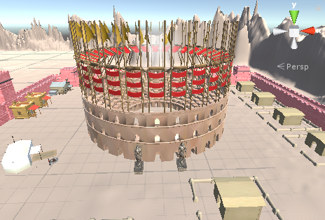

Figure 38 Arena

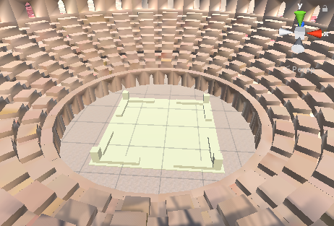

Figure 39 Stage

Beach House contains 11 different elements.

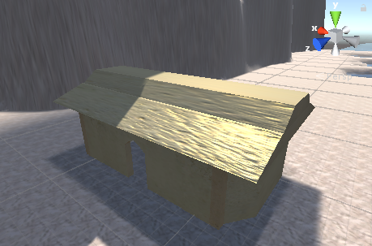

Figure 40 Beach House

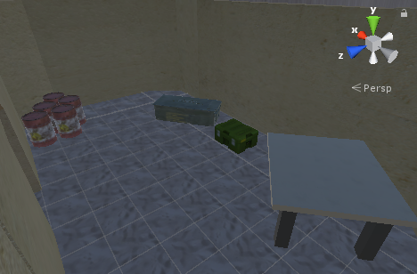

Figure 41 Beach House Interior

Reward Maze contains 15 different elements.

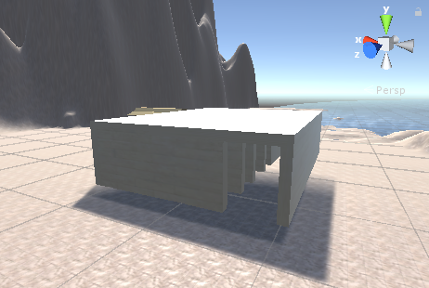

Figure 42 Reward Maze

#### Add lighting sources (at least 10 units, with different settings, such as: color, intensity, etc.).

I’ve added 10 lighting sources: two in the reward maze, one in the beach house, two in the stronghold, one in rocky household, one over pyramid and three in the city. Here’s a picture of their locations.

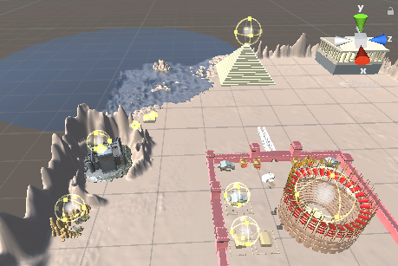

Figure 43 Regijus’ lighting sources

Lighting sources settings:

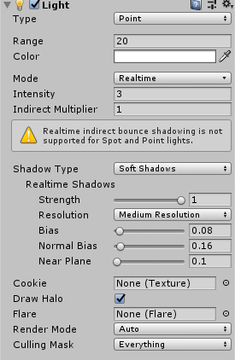

Figure 44 Stronghold lighting source

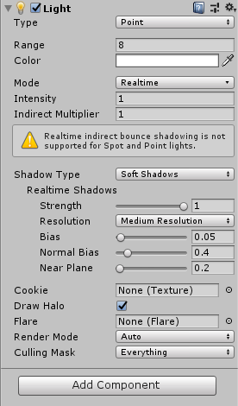

Figure 45 Stronghold interior lighting source

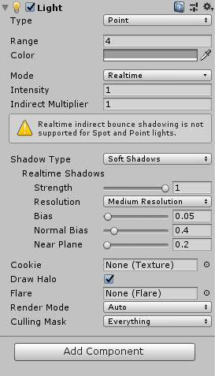

Figure 46 Reward labyrinth Interior lighting source

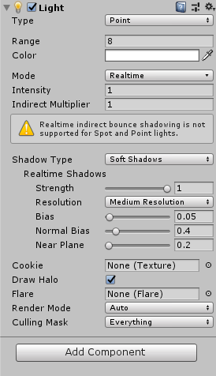

Figure 47 Reward labyrinth lighting source

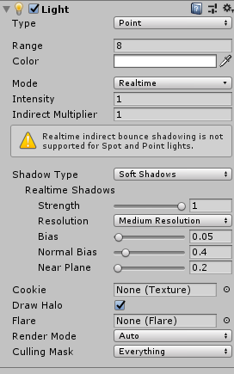

Figure 48 Beach house lighting source

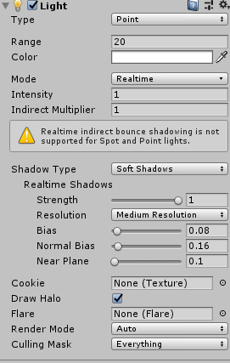

Figure 49 Rocky household lighting source

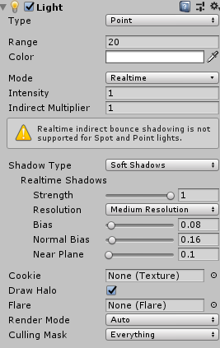

Figure 50 City entrance lighting source

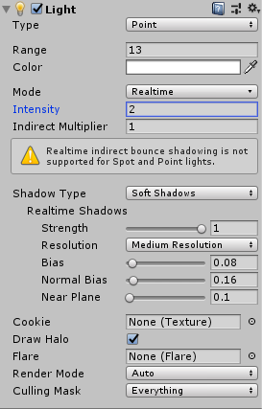

Figure 51 Store lighting source

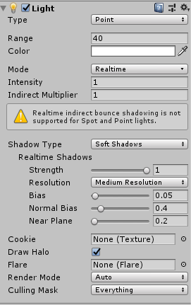

Figure 52 Arena lighting source

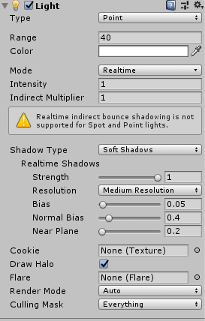

Figure 53 Pyramid lighting source

So pretty much every light source I’ve added had different intensity, range and shadow properties. Every lighting source’s color was white, except one in reward labyrinth, which is grey.

#### Complement the map with sound (at least 10 different sounds and at least 5 pieces of background music in different locations).

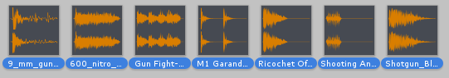

Figure 54 Gunshot sounds

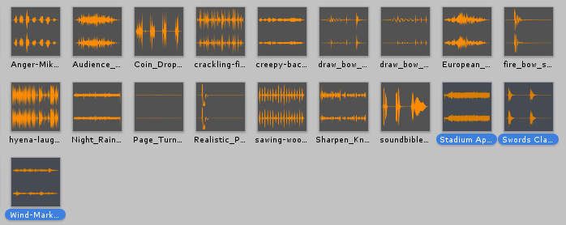

Figure 55 Sound effects

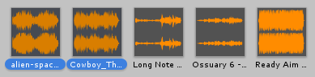

Figure 56 Theme music

Settings:

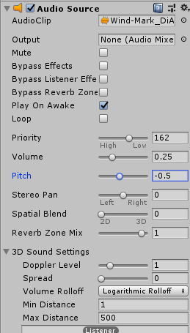

Figure 57 Wind audio settings

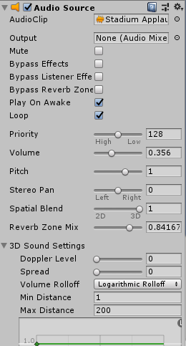

Figure 58 Stadium audio settings

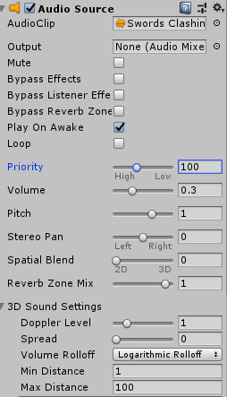

Figure 59 Swords clashing audio settings

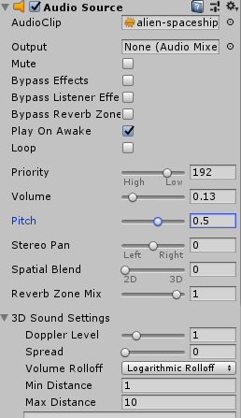

Figure 60 Alien spaceship theme audio settings

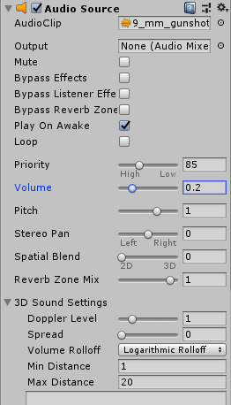

Figure 61 9mm audio settings

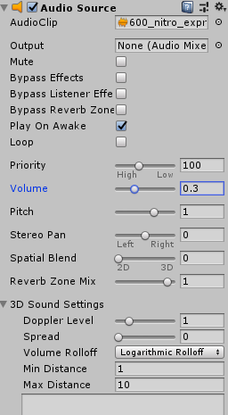

Figure 62 600 Nitro audio settings

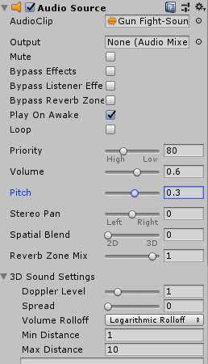

Figure 63 Gun fight audio settings

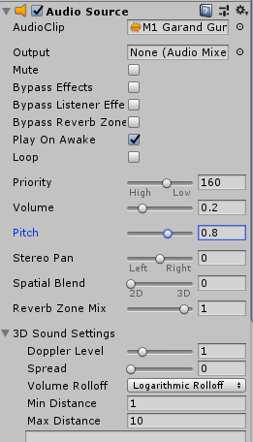

Figure 64 M1 Garand Gun audio settings

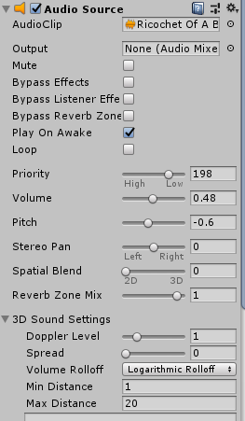

Figure 65 Ricochet of a bullet audio settings

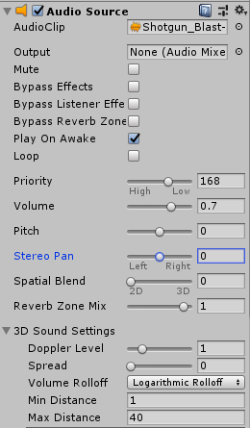

Figure 66 Shotgun audio settings

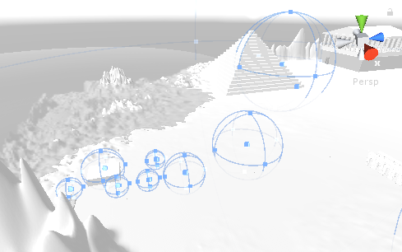

Figure 67 Sound locations

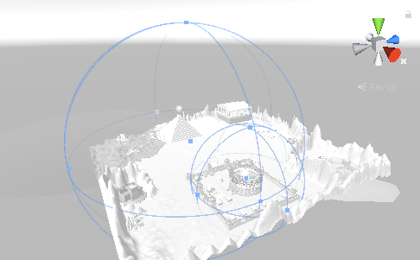

Figure 68 Sound locations

#### Use at least 20 different materials (excluding asset store content).

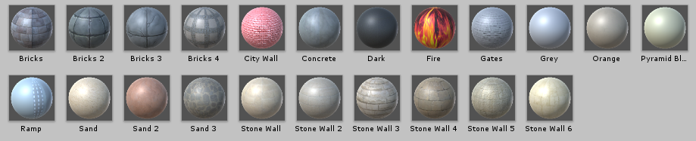

Figure 69 Regijus’ materials

#### Defense task

Add green light in the city so that city walls would be light’s borders. I’ve completed the task by using rectangle shaped area light with green color property.

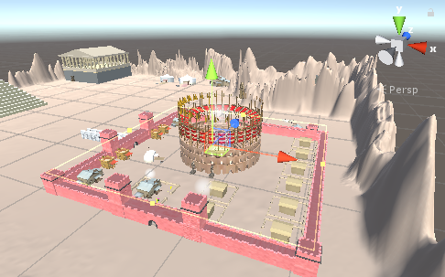

Figure 70 Defense task’s light location

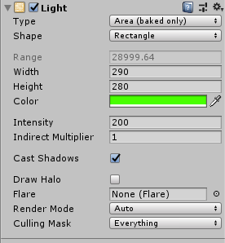

Figure 71 Defense task’s lighting source settings

### Tomas Volkevičius

#### Create a map in at least 10x10 scenario elements.

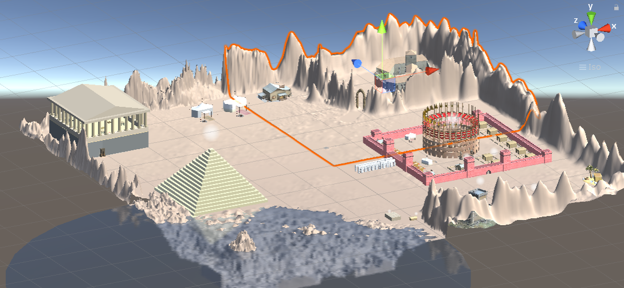

Figure 72 Tomas's plane

Marked plane is the one I have done most of my work

#### Choose your Style. Add at least 50 environmental elements.

Variety of objects contain more than one element, e.g., fence or stool figures. Assets added: 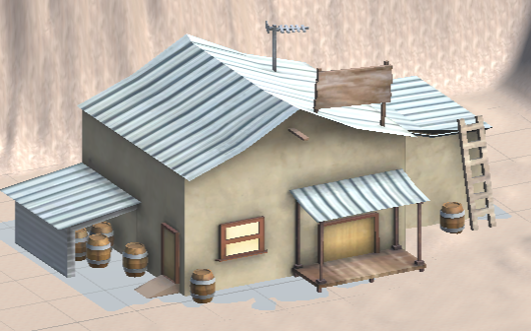

Figure 73 Sample asset added

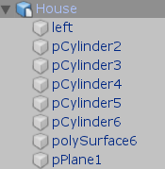

Figure 74 Objects of the asset

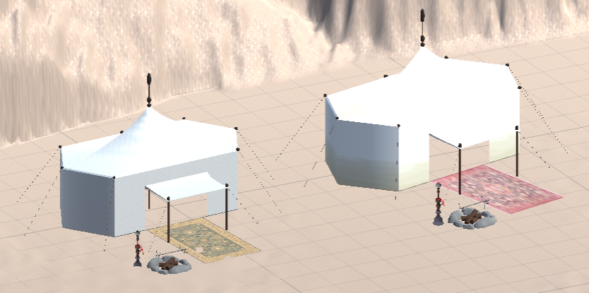

Figure 75 Sample asset added

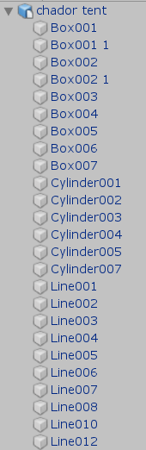

Figure 76 List of objects in the asset part 1

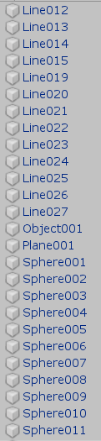

Figure 77 List of objects in the asset part 2

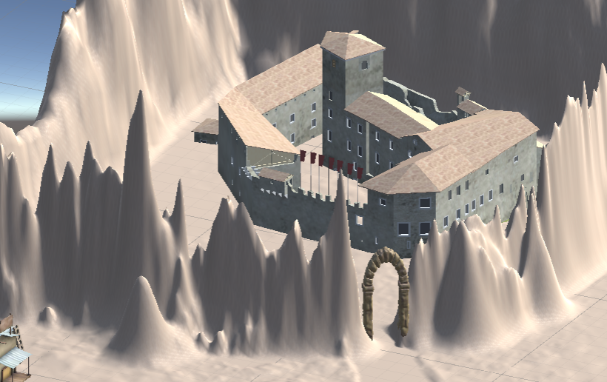

Figure 78 Sample asset added

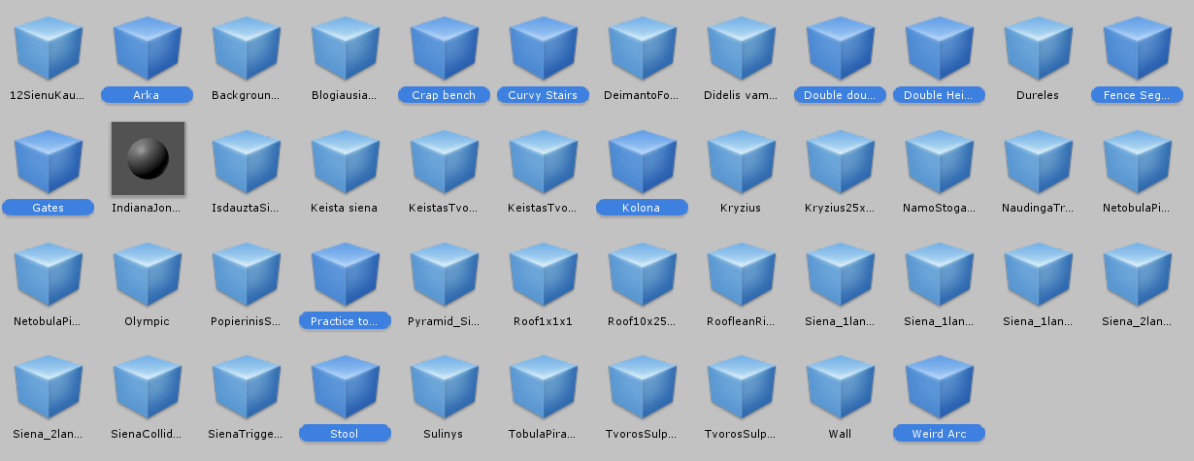

Figure 79 11 assets which have not been used yet (marked)

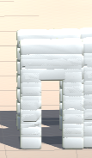

Figure 80 Sample asset added



Figure 81 Objects of the asset

#### Add lighting sources (at least 10 units, with different settings, such as: color, intensity, etc.)

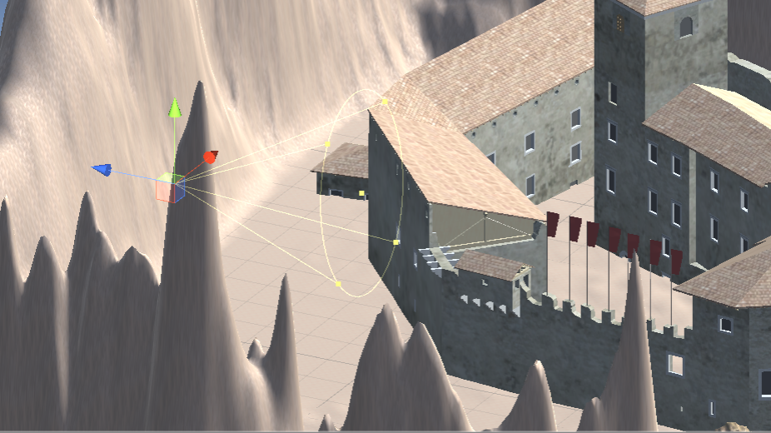

Figure 82 Light on the castle

Further figures represent options of the same type of lightnings used on the same object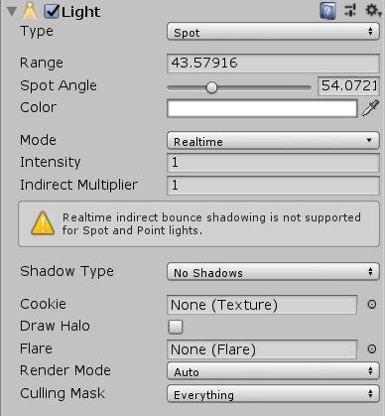

Figure 83 Options of lightning

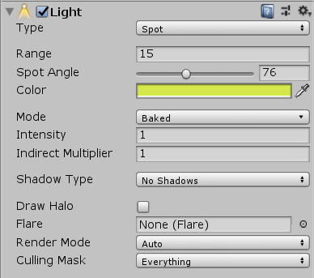

Figure 84 Options of lightning

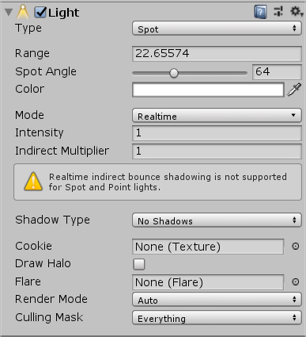

Figure 85 Options of lightning

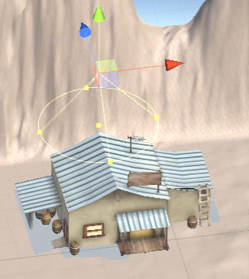

Figure 86 Light on the house

Further figures represent options of the same type of lightnings used on the same object

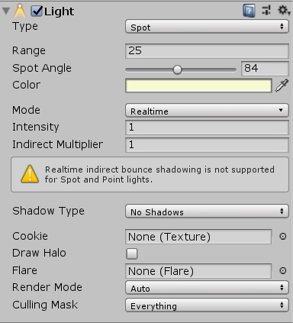

Figure 87 Options of lightning

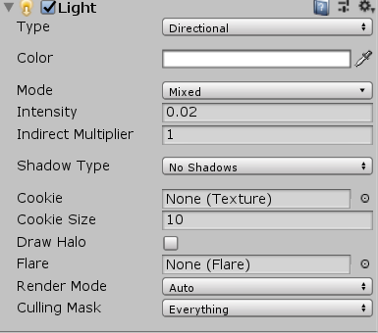

Figure 88 Options of lightning

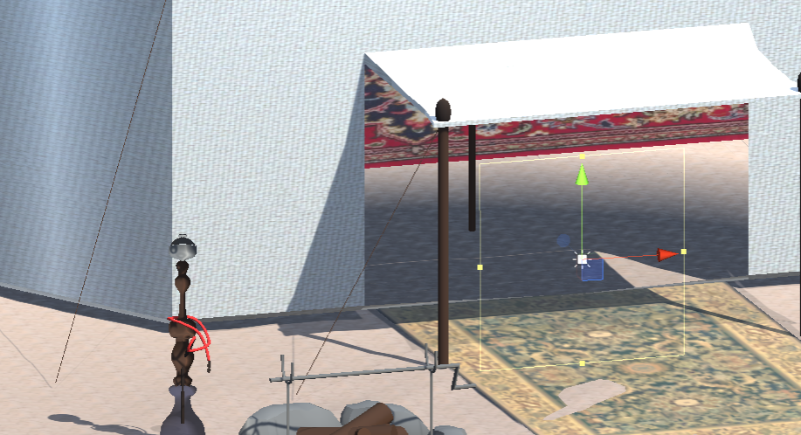

Figure 89 Lightning in the tent

Further figures represent options of the same type of lightnings used on the same object. There are two tents in total.

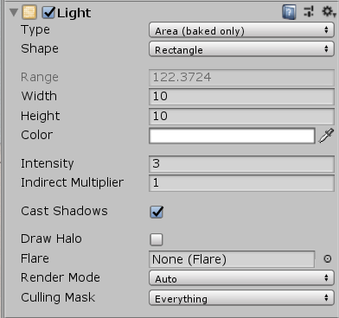

Figure 90 Options of the lightning

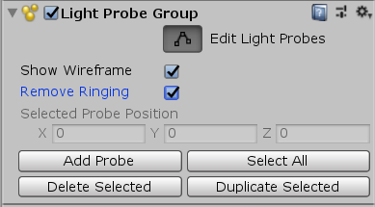

Figure 91 Options of the lightning

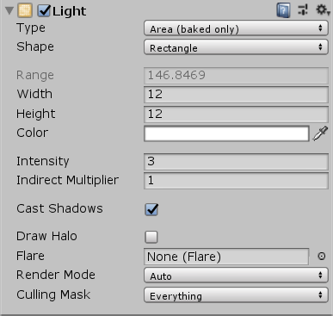

Figure 92 Options of the lightning

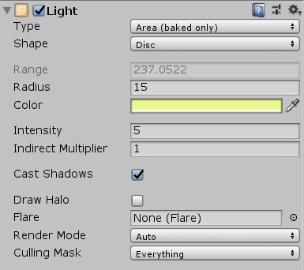

Figure 93 Options of the lightning

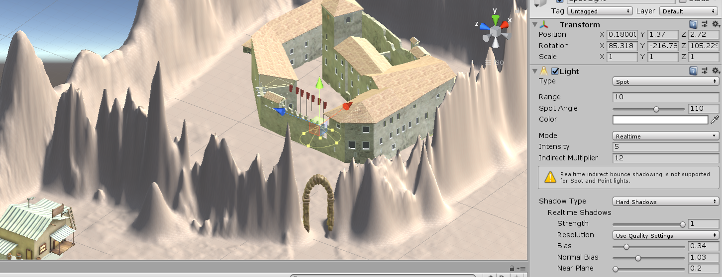

Figure 94 Lightning over the gates with lightning options on the side

#### Complement the map with sound (at least 10 different sounds and at least 5 pieces of background music in different locations).



Figure 95 Audio sounds used

Further figures represent audio options used in different areas of the map

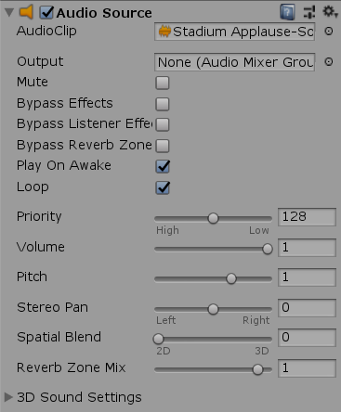

Figure 96 Audio options (applause)

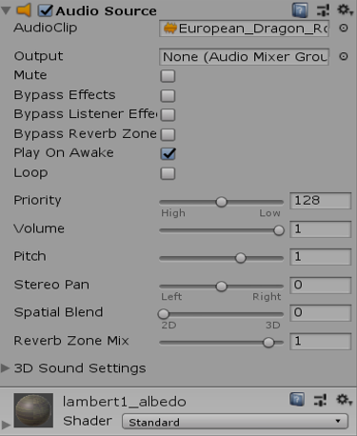

Figure 97 Audio options (dragon sounds)

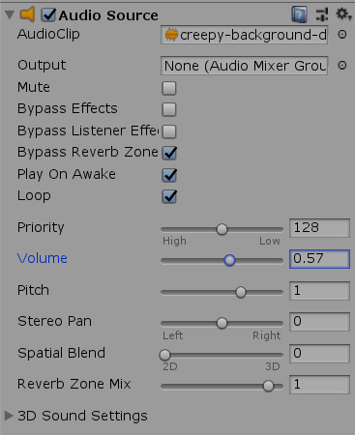

Figure 98 Audio options (creepy background)

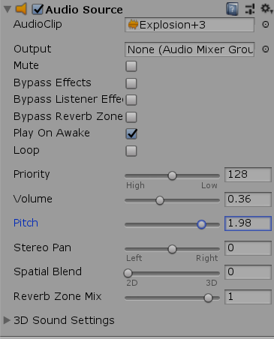

Figure 99 Audio options (background sounds)

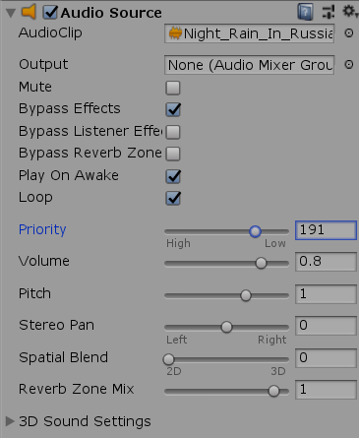

Figure 100 Audio options (rain sounds)

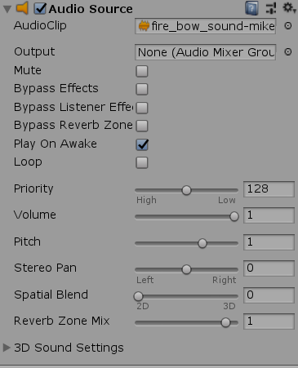

Figure 101 Audio options (fire bow sounds)

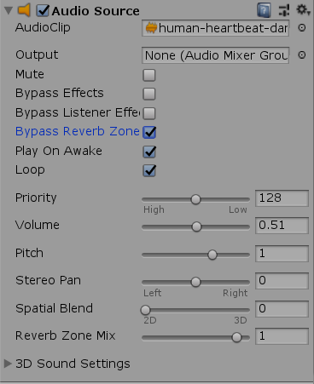

Figure 102 Audio options (heartbeat sounds)

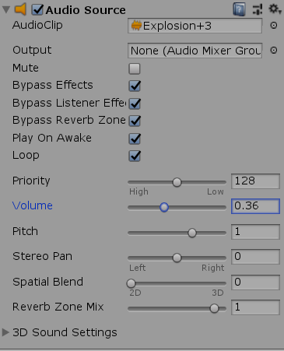

Figure 103 Audio options (explosions sounds)

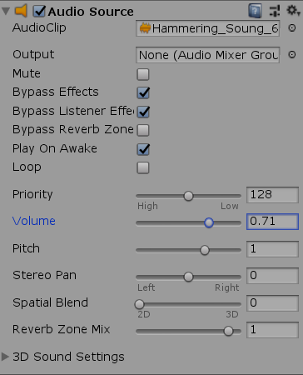

Figure 104 Audio options (hammering sounds)

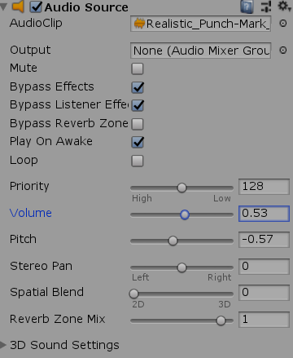

Figure 105 Audio options (punch sounds)

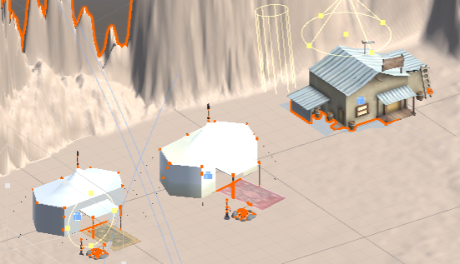

Figure 106 Example of audio locations 1

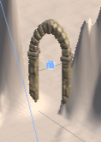

Figure 107 Example of audio locations 2

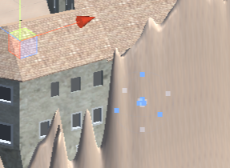

Figure 108 Example of audio locations 3

#### Use at least 20 different materials (excluding asset store content).

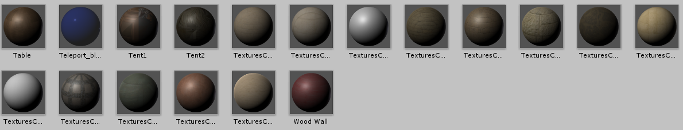

Figure 109 materials added / used

#### Defense task

Create a blank project. Add a new plane (any size). Add two area lights parallel to the plane. Both of the area lights should be in different colors. Have a view of how the plane is enlightened.

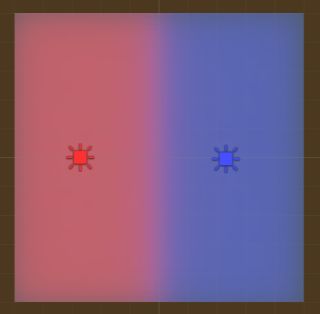

Figure 110 Result of defense task

### Jurgis Petrauskas

#### Create a map in at least 10x10 scenario elements.

I worked on whole map, not only 10x10 size plane/terrain.

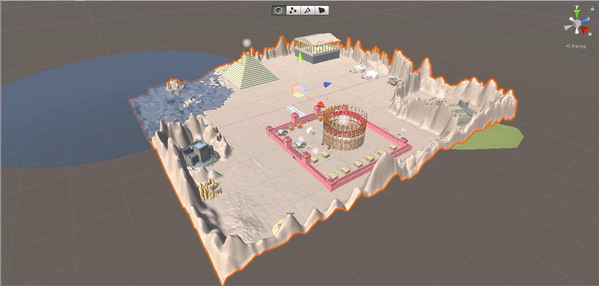

Figure 111 Map

#### Choose your Style. Add at least 50 environmental elements.

Most of the environmental elements are made up from few elements, f.e. “Desert well” is made from 9 components.

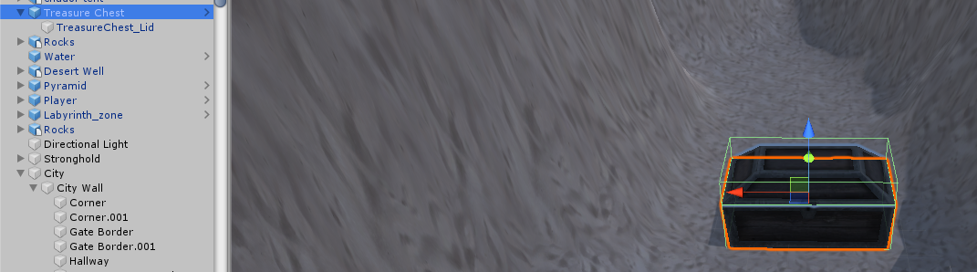

Figure 112 Treasure Chest

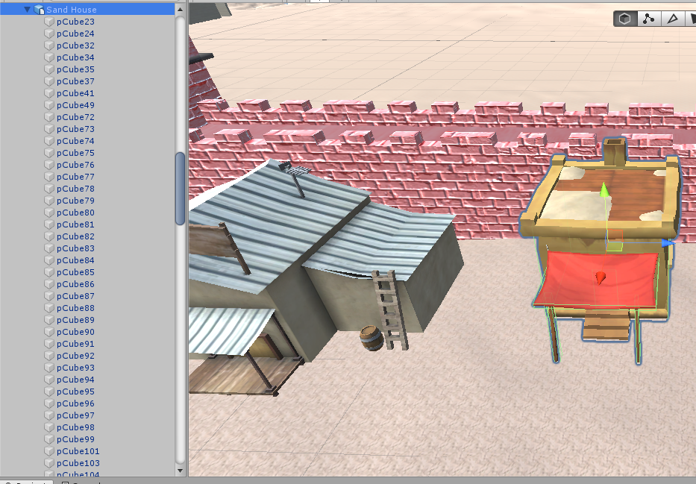

Figure 113 Sand house

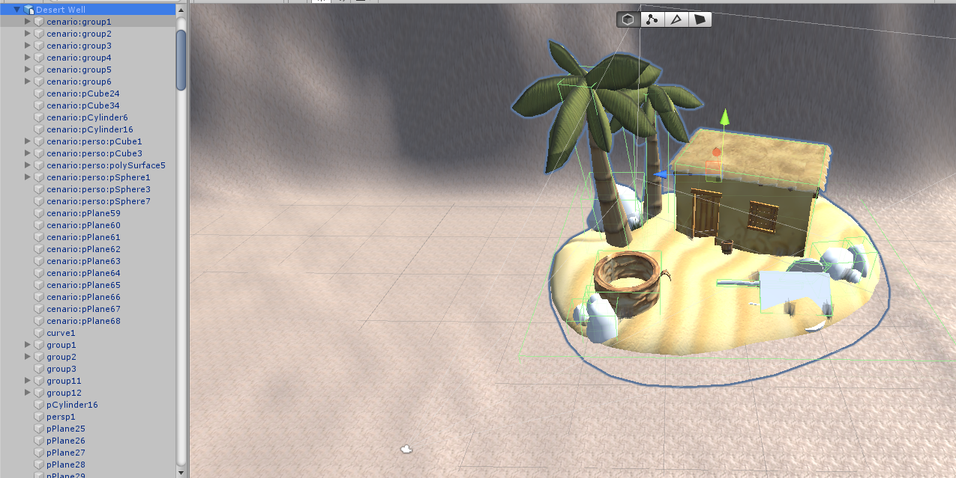

Figure 114 Desert well

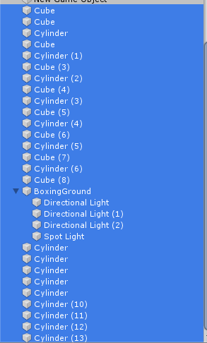

Figure 115 Hierarchy of assets

#### Add lighting sources (at least 10 units, with different settings, such as: color, intensity, etc.)

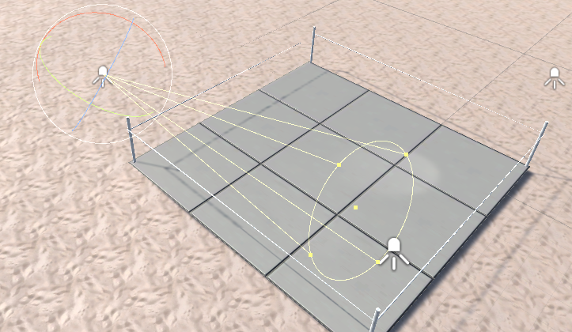

Figure 116 Lightning above boxing ring

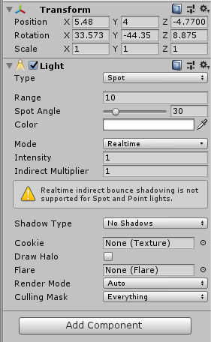

Figure 117 Spotlight properties

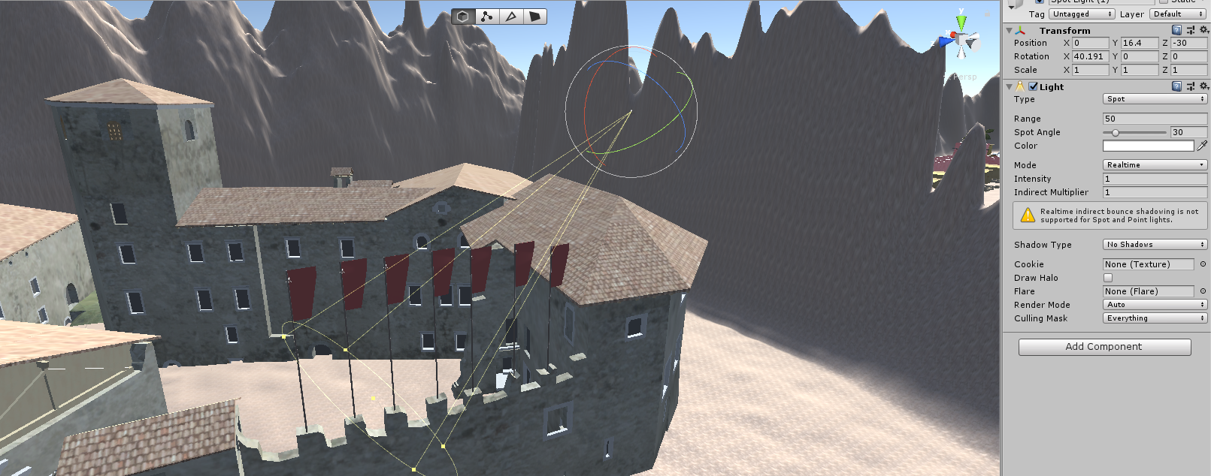

Figure 118 Spotligh

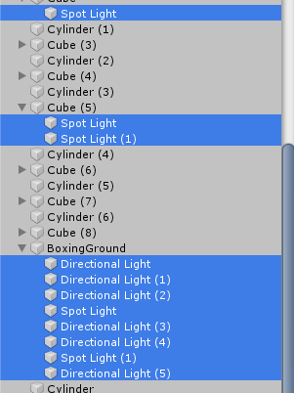

Figure 119 Spotlight hierarchy

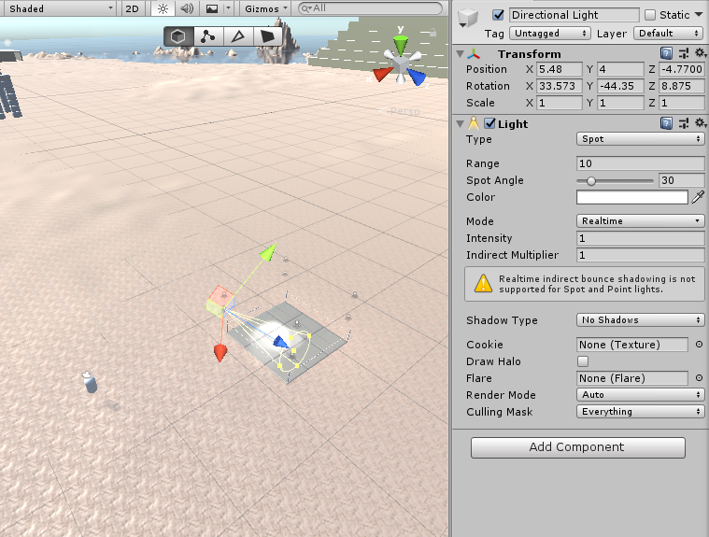

Figure 120 Directional Light

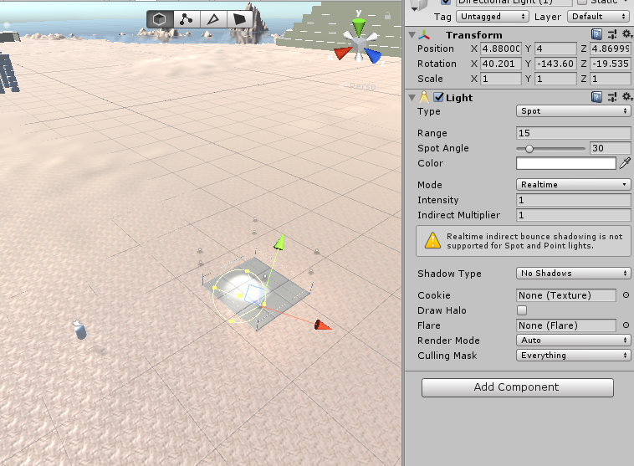

Figure 121 Directional Light(1)

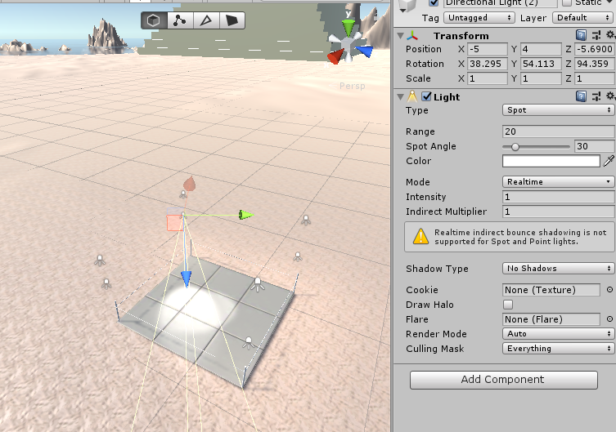

Figure 122 Directional Light(2)

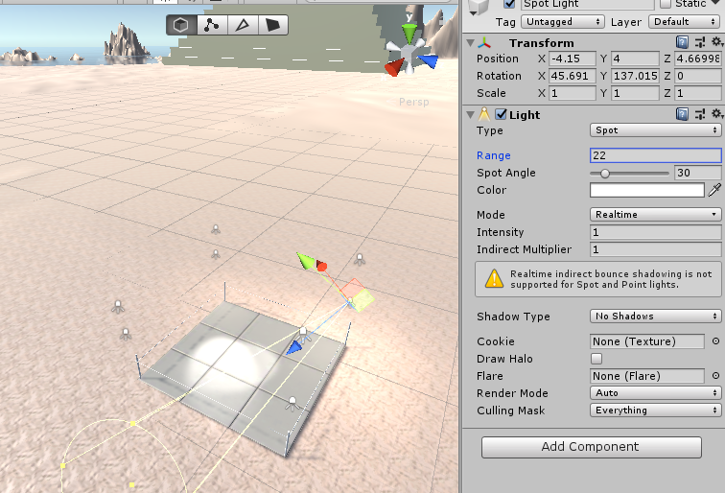

Figure 123 Spot Light

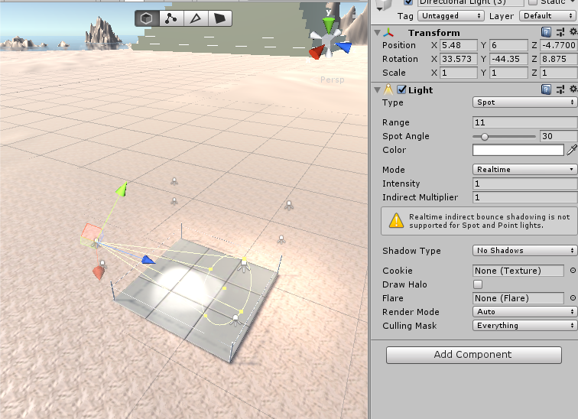

Figure 124 Directional Light(3)

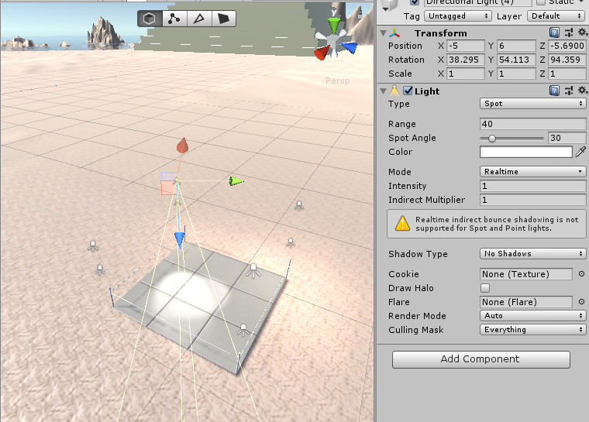

Figure 125 Directional Light (4)

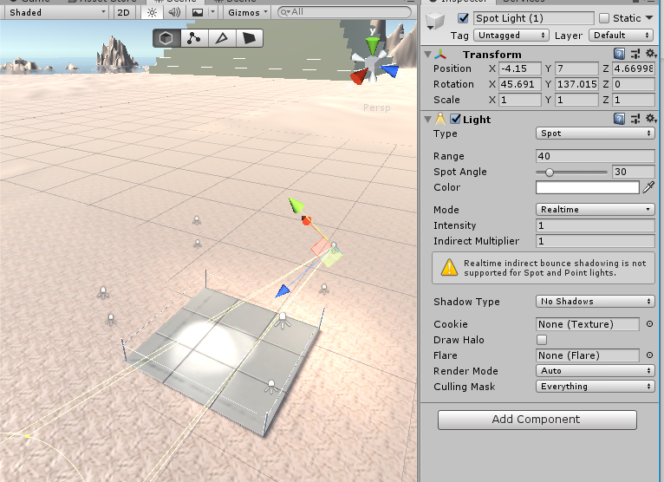

Figure 126 Spot Light(!)

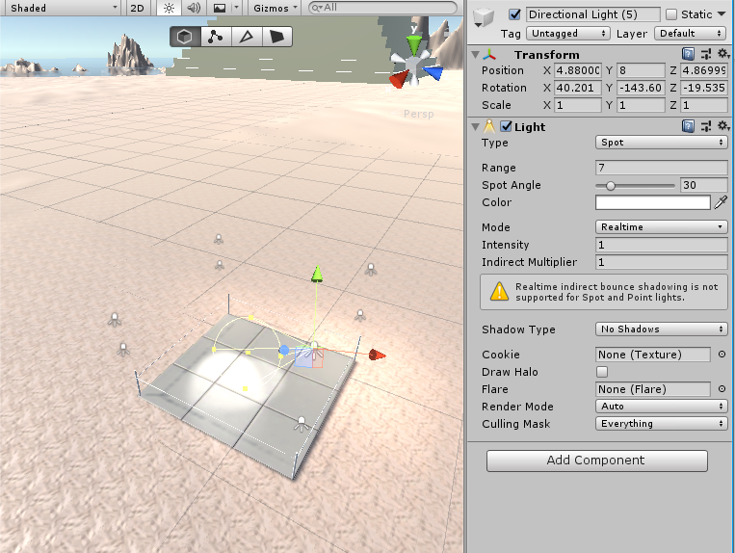

Figure 127 Directional Light (5)

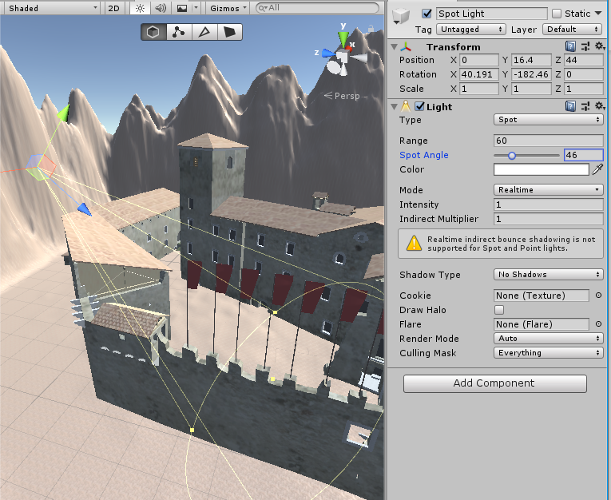

Figure 128 SpotLight

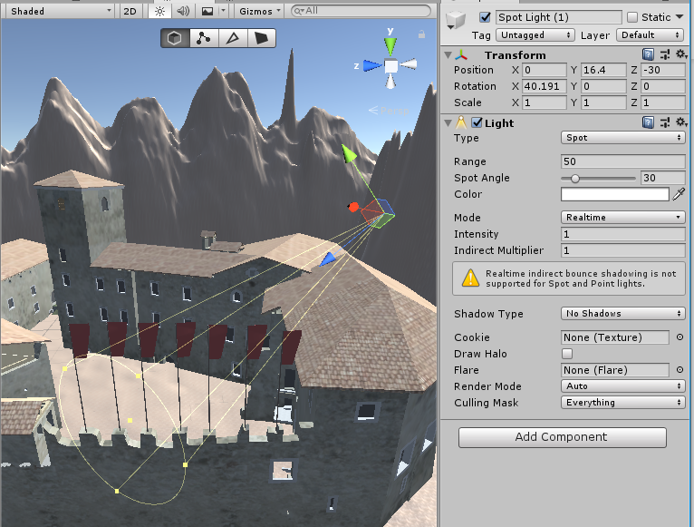

Figure 129 SpotLight(1)

#### Complement the map with sound (at least 10 different sounds and at least 5 pieces of background music in different locations).



Figure 130 Sounds

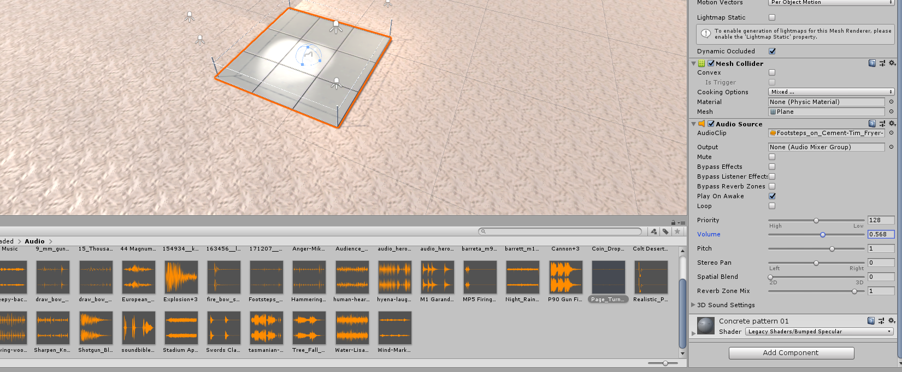

Figure 131 Audio of boxing area

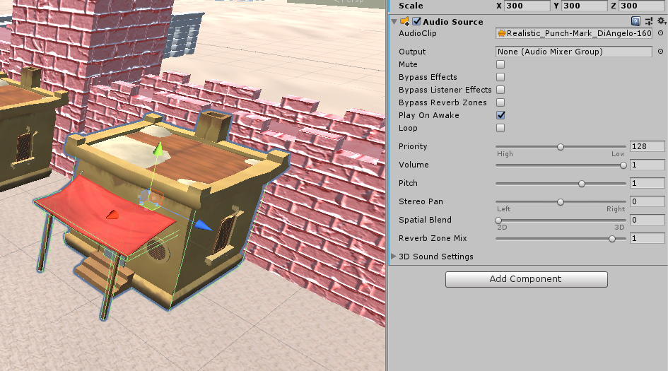

Figure 132 Sound of Sand house

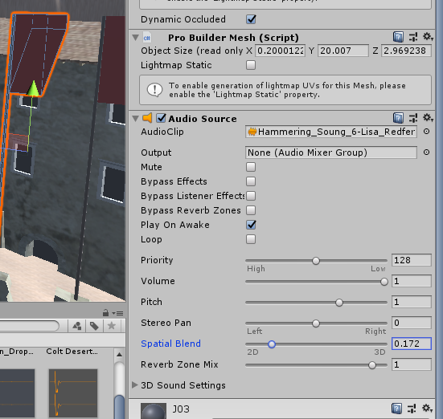

Figure 133 Sound of flag

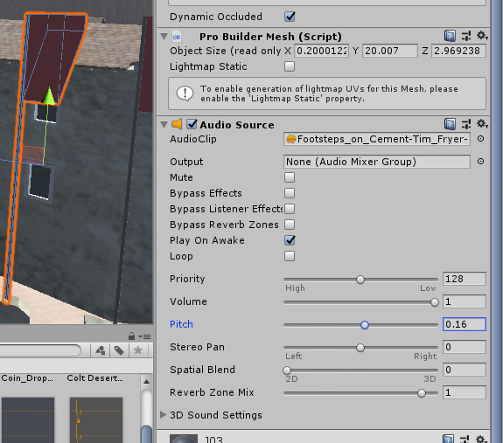

Figure 134 Sound of a flag

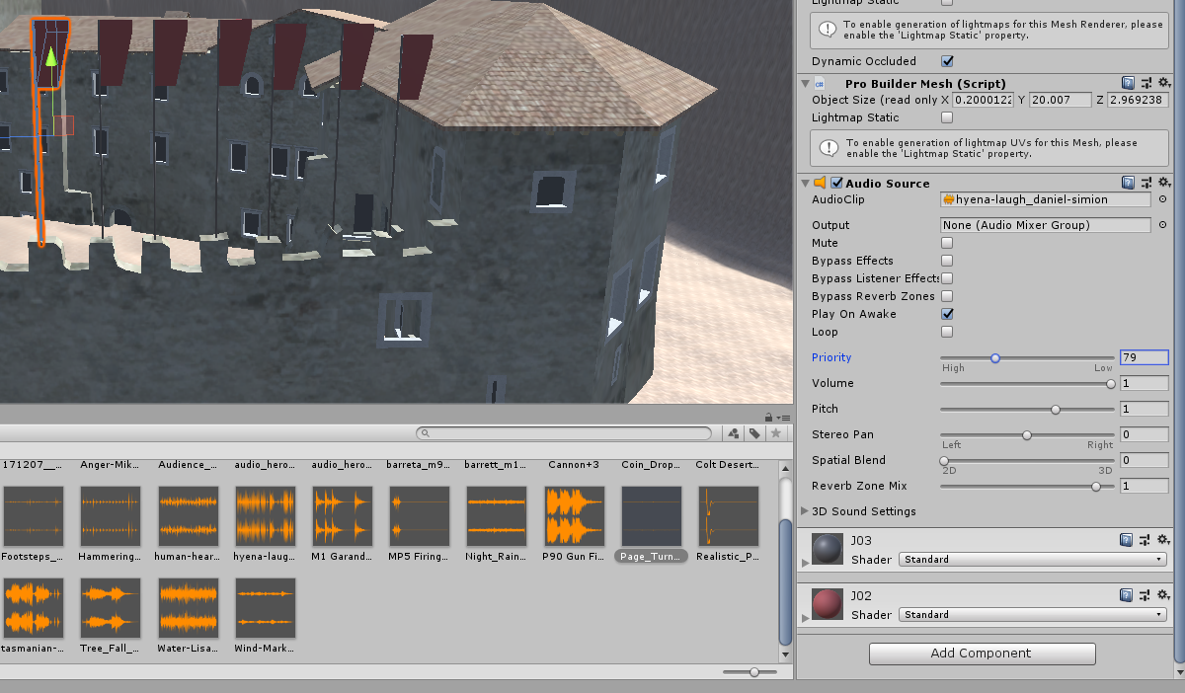

Figure 135 Sound of a flag

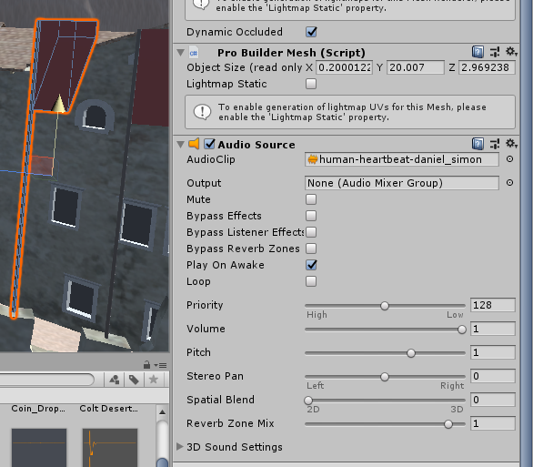

Figure 136 Sound of a flag

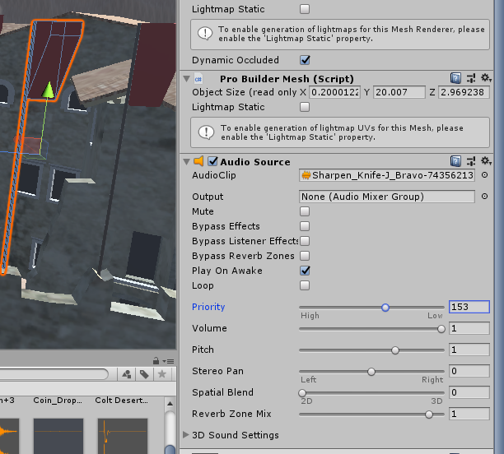

Figure 137 Sound of a flag

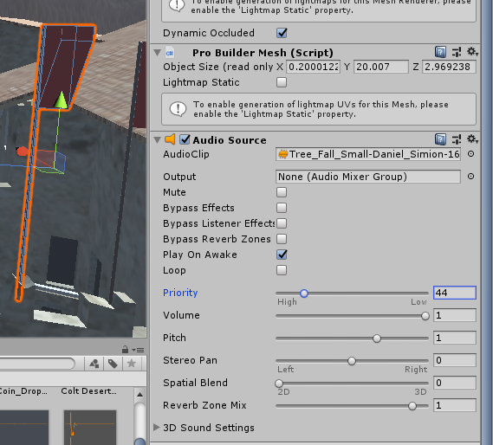

Figure 138 Sound of a flag

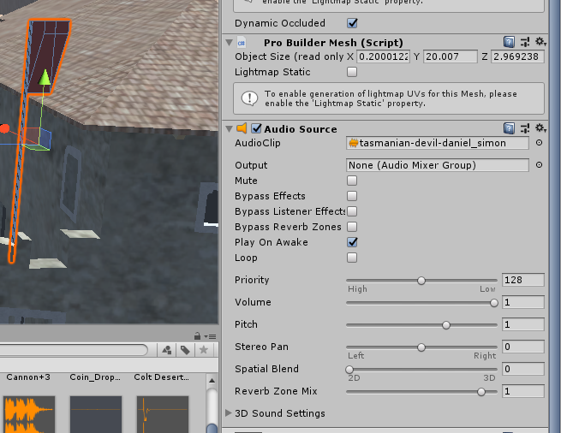

Figure 139 Sound of a flag

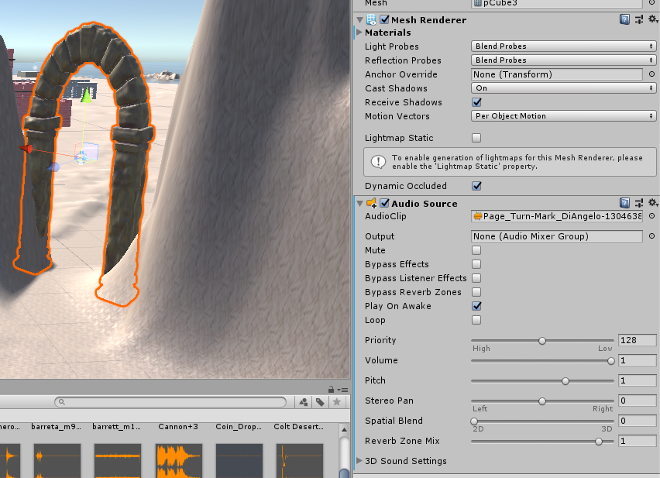

Figure 140 Sound of arch

#### Use at least 20 different materials (excluding asset store content).

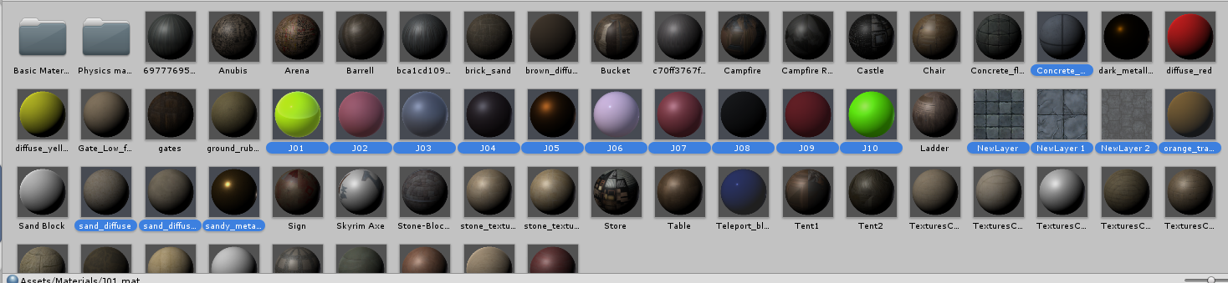

Figure 141 selected materials

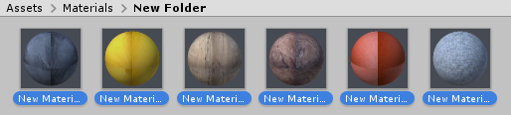

Figure 142 materials created

#### Defense task

Override sound to fit area and increase sound in middle using custom volume rolloff

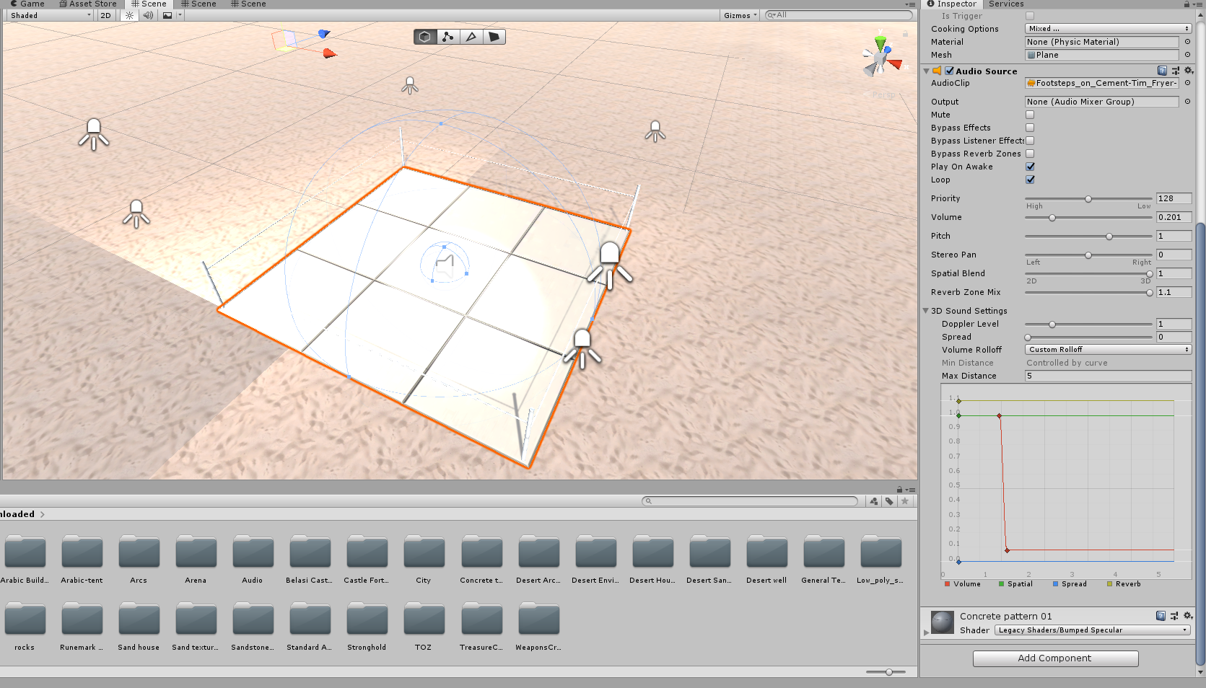

Figure 143 Defence task. Properties of audio and its visualisation

### Benas Bernadišius

#### Create a map in at least 10x10 scenario elements.

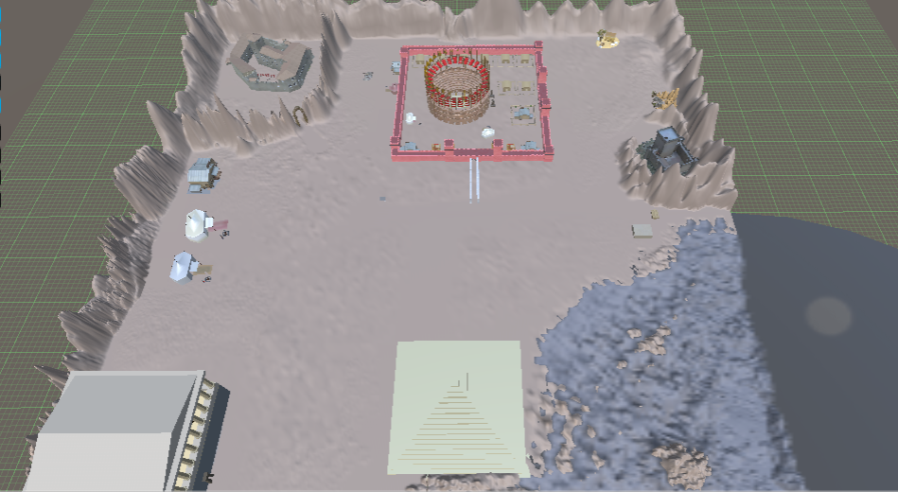

I contributed with:

Assets in the red city (filler buildings around the arena)

Modifying the red wall to make the city more accessible.

Whole south-east region’s terrain including water, some buildings outside the city as tents, rocks.

Modifying the terrain of the entire map, adding hills, smoothing it, smoothing the bordering terrain.

#### Choose your Style. Add at least 50 environmental elements.

I created around 38 assets for use in building the map. The assets include such things as walls, walls with windows, several types of rooftops, materials for building fences, houses, a very simplistic model of a car, materials for building pyramids. etc.

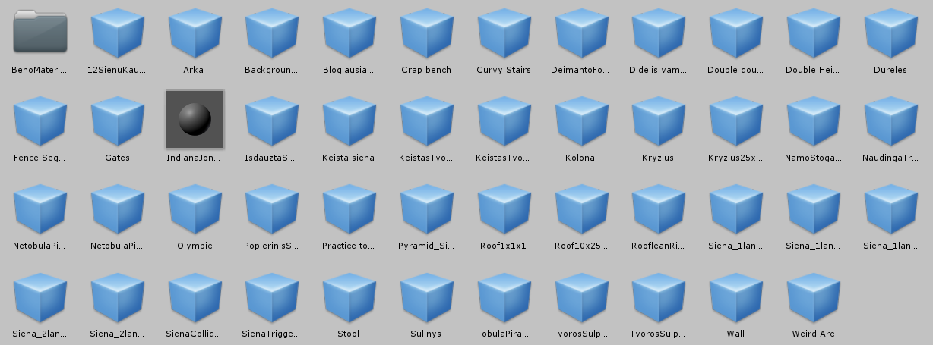

Figure 144 35 of the visible custom assets were created by me.

However, I preferred using other assets who are made by more professional people in the industry.

I added such elements as these tents to fill out the map:

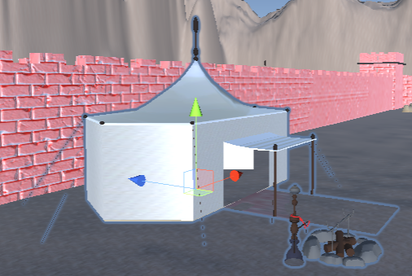

Figure 145 example asset "arabic tent"

#### Add lighting sources (at least 10 units, with different settings, such as: color, intensity, etc.)

The inspector side of the lights I added around the entrance of the city:

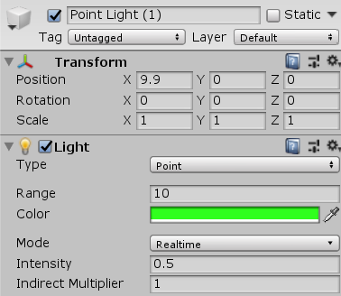

Figure 146 Light 1

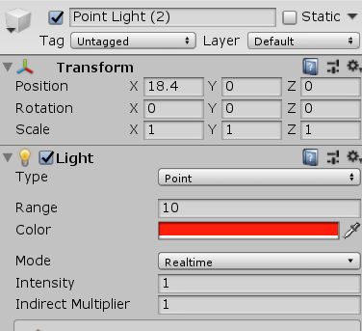

Figure 147 Light 2

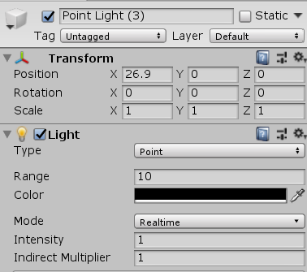

Figure 148 Light 3

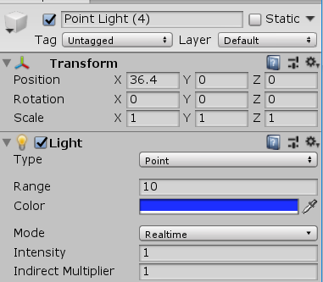

Figure 149 Light 4

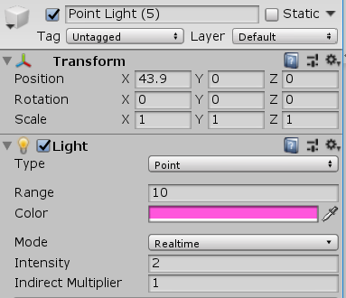

Figure 150 Light 5

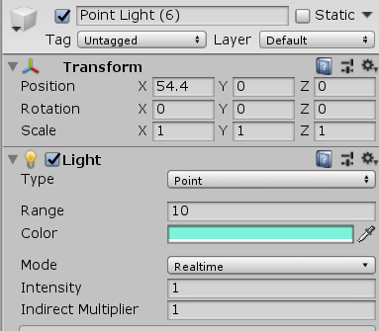

Figure 151 Light 6

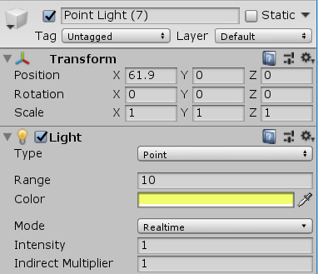

Figure 152 Light 7

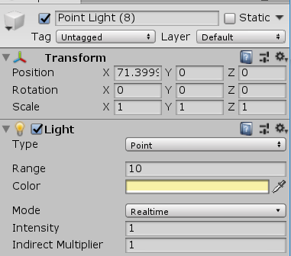

Figure 153 Light 8

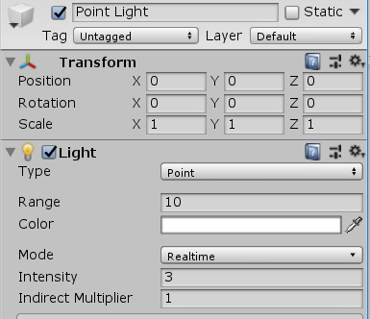

Figure 154 Light 9

#### Complement the map with sound (at least 10 different sounds and at least 5 pieces of background music in different locations).

I added the selected sound effects into our project and used some of them just for testing purposes:

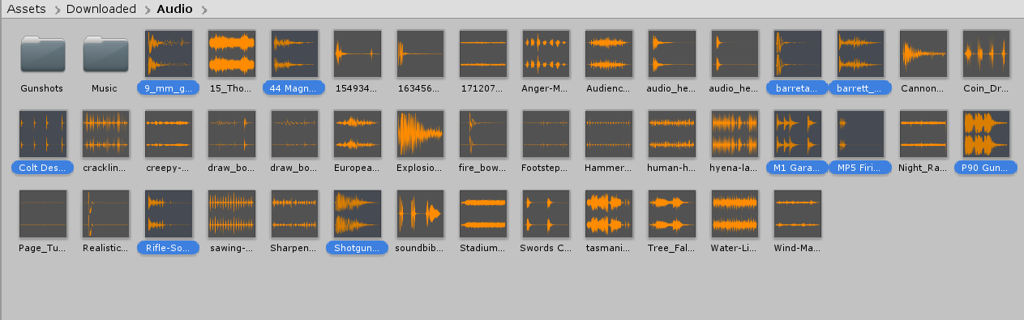

Figure 155 Imported audio files

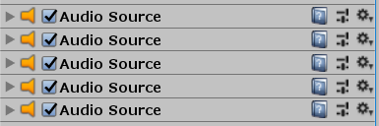

Figure 156 Used audio files

#### Use at least 20 different materials (excluding asset store content).

I created around 16 materials out of pictures and different basic settings ( adding a metallic-shader, playing around with color, etc.)

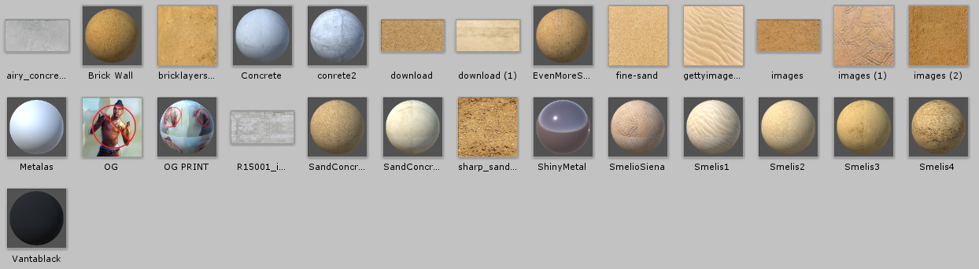

Figure 157 Custom-made materials

#### Defense task

None as of yet.

# Laboratory Work #2

## List of Tasks

TERRAIN, etc.

1. Create a terrain and color it using 5 or more materials of your own design;
2. Create 5 trees of your own construction and seed them using terrain tools;

ANIMATION

1. IMPORT a unique model and assign it to a third person character controller;
2. Add and animate 5 objects to your game maps;

SPECIAL EFFECTS

1. Create 5 unique (non-factory) particle effects (fire, portal, etc.);
2. Add a CUSTOM SKYBOX

PHYSICS

1. Create 5 different physics materials and apply them in your project;
2. Assign an optimum collider based on the shape of the object for all 3D objects imported in the first laboratory work;
3. Add and animate 5 objects using PHYSICS, FORCE and TRIGGERS to your game maps (traps, falling objects, moving doors, etc);

OPTIMIZATION (Benchmark your game BEFORE any modifications)

1. Set static flag to all immobile objects and measure batching performance;
2. Try deferred vs forward rendering and measure performance for both;
3. Bake a lightmap for your scene and measure performance;
4. Optimize all textures depending on their parameters and measure graphical memory load;
5. Try hard vs soft shadows, different quality settings and measure the performance;

## Solution

### Regijus Borodinas

#### Terrain part

* 1. Create a terrain and color it using 5 or more materials of your own design.

I’ve formed mountains on the terrain and colored it using 5 sand texture materials.

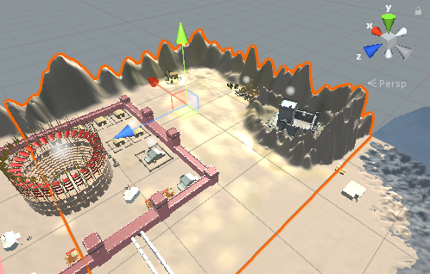

Figure 158 Regijus’ terrain

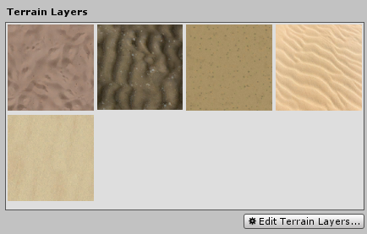

Figure 159 Regijus’ terrain layers

* 1. Create 5 trees of your own construction and seed them using terrain tools.

I’ve created 5 unique trees and added different textures to them.

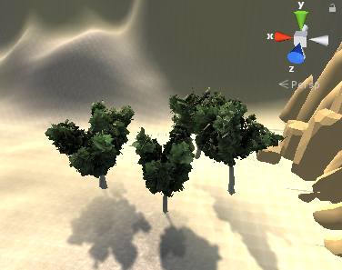

Figure 160 Regijus’ trees

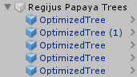

Figure 161 Regijus’ trees in hierarchy

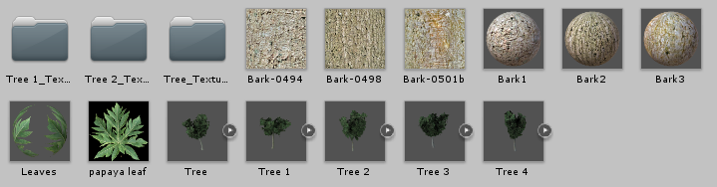

Figure 162 Tree materials and textures

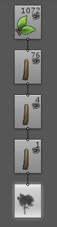

Figure 163 Example of tree hierarchy

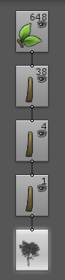

Figure 164 Example of tree hierarchy

Other trees are pretty much the same except the number of branches and leaves. I’ve changes the parameters of every tree (like spread, offset, crinkliness, seek sun etc).

#### Animation part

* 1. Import a unique model and assign it to a third person character controller

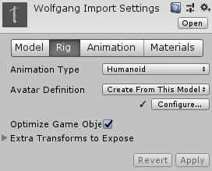

Figure 165 Model rigging

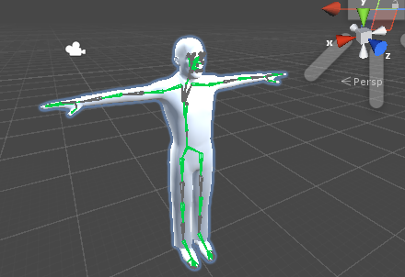

Figure 166 Model bone system

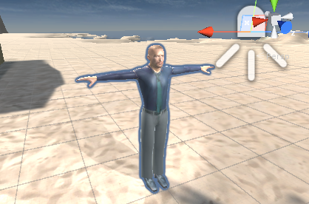

Figure 167 Model in game

* 1. Add and animate 5 objects to your game maps

I’ve animated 7 different objects, created the “wind effect” on trees and cactuses to fit with the game theme.

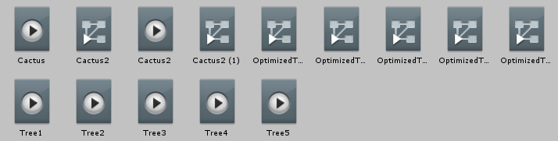

Figure 168 Regijus’ animations

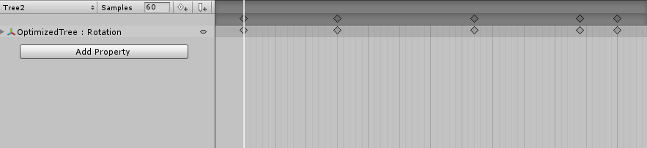

Figure 169 Animation 1

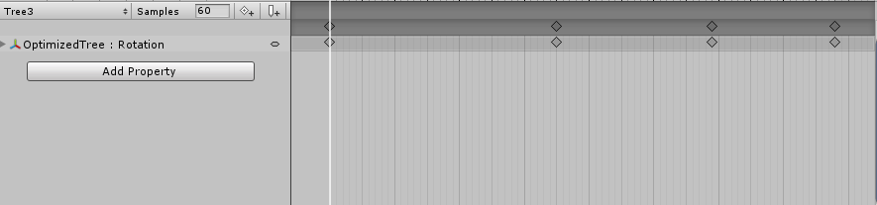

Figure 170 Animation 2

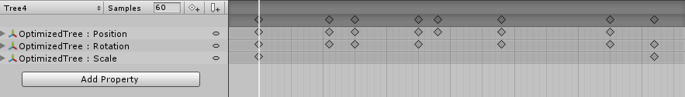

Figure 171 Animation 3

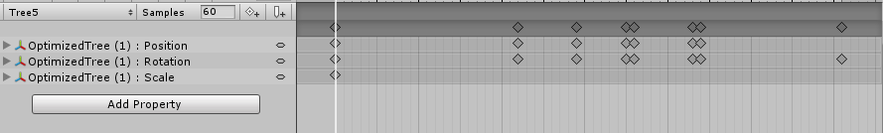

Figure 172 Animation 4

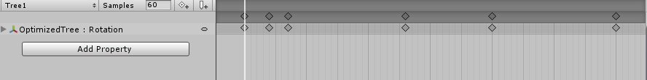

Figure 173 Animation 5

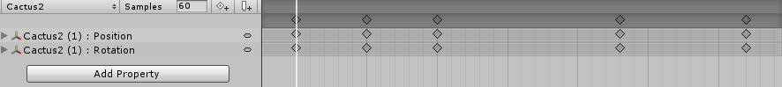

Figure 174 Animation 6

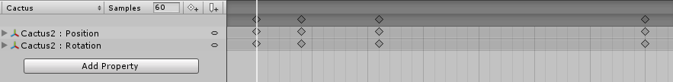

Figure 175 Animation 7

#### Special Effects part

* 1. Create 5 unique (non-factory) particle effects (fire, portal, etc.)

I’ve created 5 different effects, played with parameters a lot to get what I wanted.

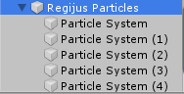

Figure 176 Regijus’ effects

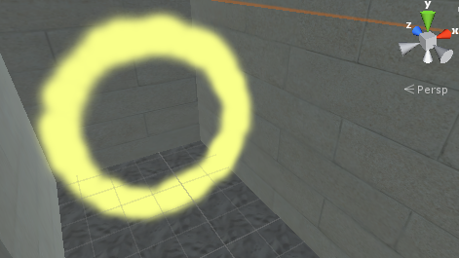

Figure 177 Effect 1 – Portal

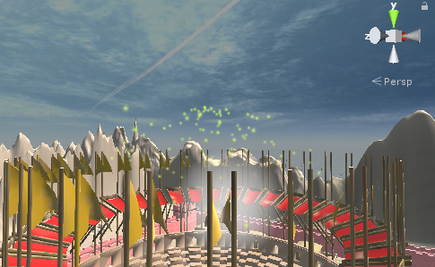

Figure 178 Effect 2 – Amber rain over the arena

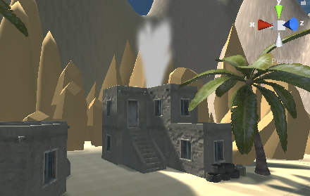

Figure 179 Effect 3 – Small chimney smoke

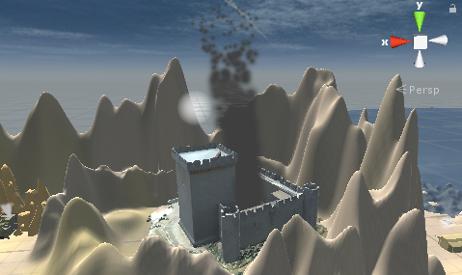

Figure 180 Effect 4 - Huge dark smoke from stronghold

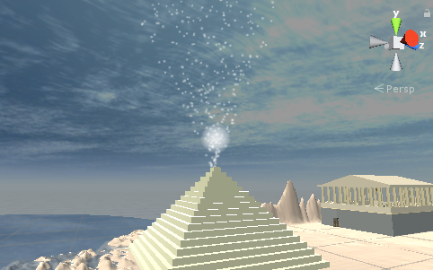

Figure 181 Effect 5 – Pyramid particle effect

* 1. Add a custom skybox

I’ve created 6-sided custom skybox.

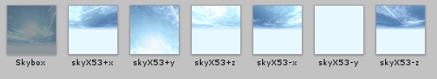

Figure 182 Regijus’ skybox textures and materials

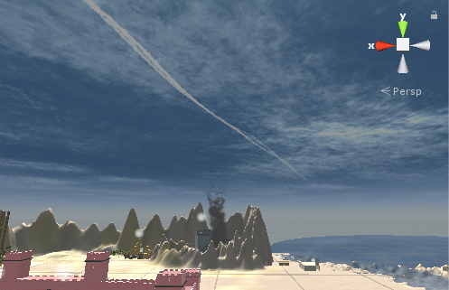

Figure 183 Regijus’ skybox

#### Physics part

* 1. Create 5 different physics materials and apply them in your project

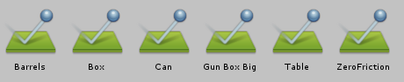

Figure 184 Regijus’ physics materials

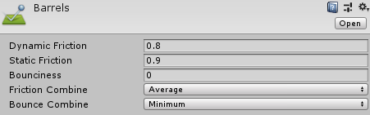

Figure 185 Physics material example

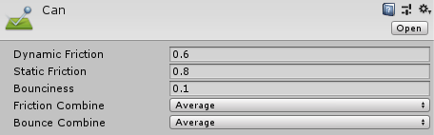

Figure 186 Another physics material example

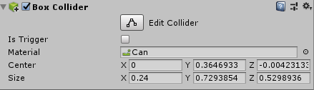

Figure 187 Example of applied physics material on object

* 1. Assign an optimum collider based on the shape of the object for all 3D objects imported in the first laboratory work

I’ve assigned optimum colliders based on the shape of objects. Some colliders are box, some mesh and even capsule colliders.

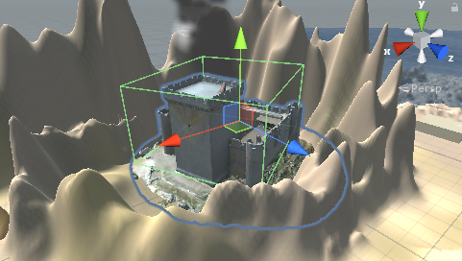

Figure 188 Stronghold collider

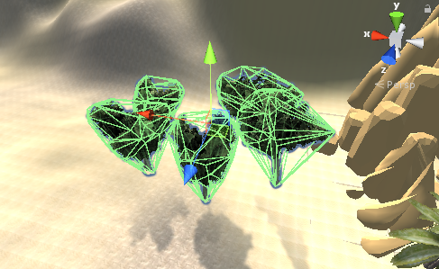

Figure 189 Papaya trees colliders

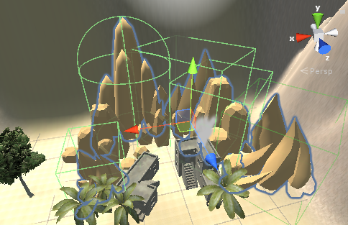

Figure 190 Rocks colliders

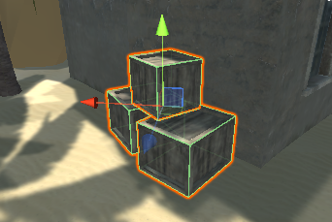

Figure 191 Boxes colliders

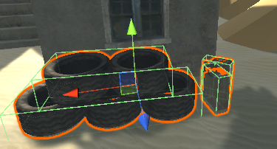

Figure 192 Tyres and jerry cans colliders

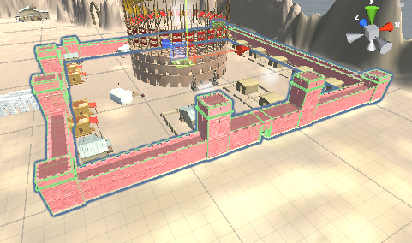

Figure 193 City wall colliders

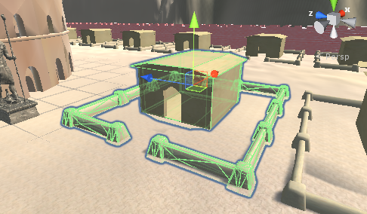

Figure 194 Simple house colliders

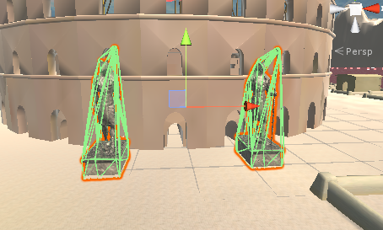

Figure 195 Anubis statues colliders

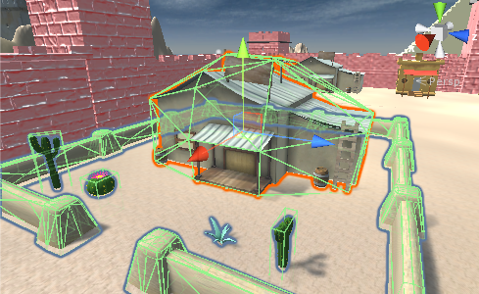

Figure 196 Store and cacti colliders

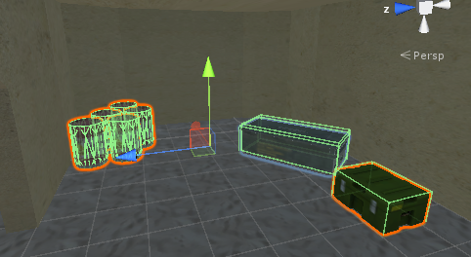

Figure 197 Beach house colliders

* 1. Add and animate 5 objects using PHYSICS, FORCE and TRIGGERS to your game maps (traps, falling objects, moving doors, etc)

I’ve animated more than 5 objects using different techniques.

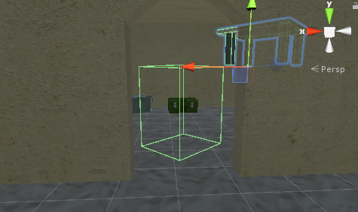

Figure 198 Table dropdown animation

When a character enters the trigger (house entrance), the table falls down from the ceiling.

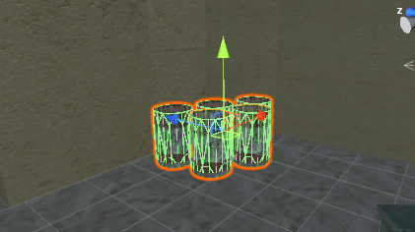

Figure 199 Barrell blow up animation

When P button is pressed, barrels “blow up” around.

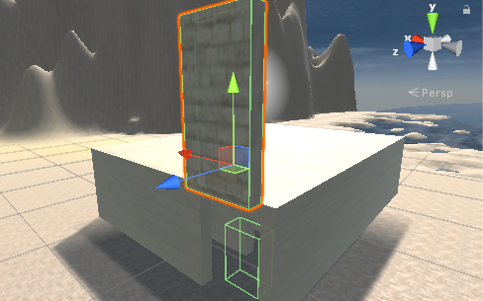

Figure 200 Maze door dropdown animation

When a character enters the trigger, maze door falls down blocking the entrance.

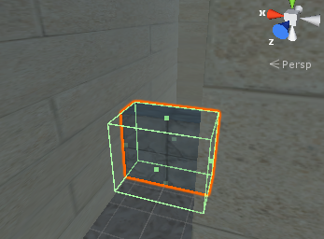

Figure 201 Disappear animation

When a character touches the trigger, he can walk through it.

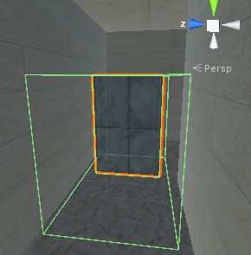

Figure 202 Move up animation

When a character touches the trigger, the block goes up, allowing player to pass the corridor.

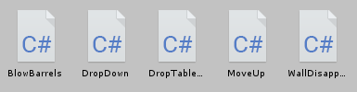

Figure 203 Regijus’ physics scripts

#### Optimization part

First of all, I’ve benchmarked my game before doing any optimizations. Here are the results.

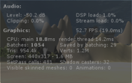

Figure 204 Regijus’ initial benchmark

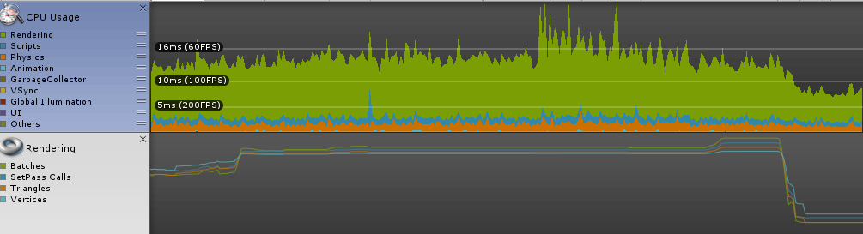

Figure 205 Regijus’ performance test

After benchmarking the game, I’ve come to the conclusion that it runs around 60 fps. Batches can be seen in figures.

* 1. Set static flag to all immobile objects and measure batching performance;

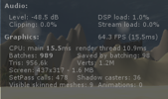

Figure 206 Regijus’ benchmark after setting static

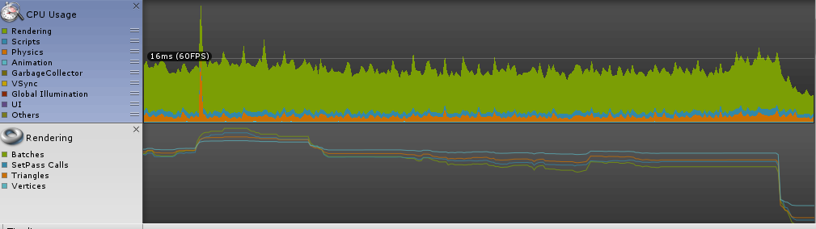

Figure 207 Regijus’ performance test after setting static

After these changes the fps has increased and there were less batches.

* 1. Try deferred vs forward rendering and measure performance for both;

First, I’ve tried deferred rendering.

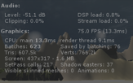

Figure 208 Regijus’ benchmark after setting deferred rendering

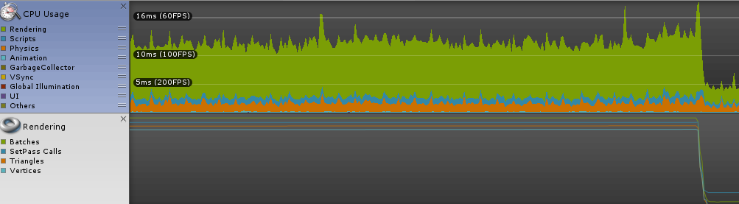

Figure 209 Regijus’ performance test after setting deferred rendering

Then I‘ve tried forward rendering option.

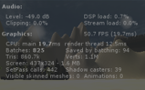

Figure 210 Regijus’ benchmark after setting forward rendering

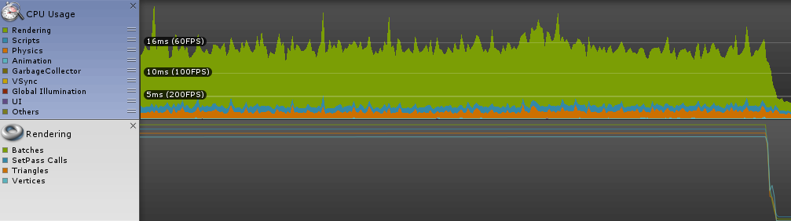

Figure 211 Regijus’ performance test after setting forward rendering

Forward rendering didn’t give me that much of a boost. I’ll stick to deferred because it does less batches and gives me more fps.

* 1. Bake a lightmap for your scene and measure performance;

First, I’ve changed lighting settings.

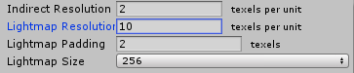

Figure 212 Regijus’ lighting settings

Then I‘ve changed lights‘ mode to baked. There‘s only one example in figures because it would all look pretty much the same anyway.

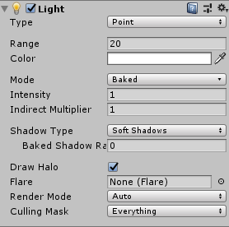

Figure 213 Regijus’ example of baked light

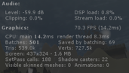

Figure 214 Regijus’ benchmark after setting baked lights

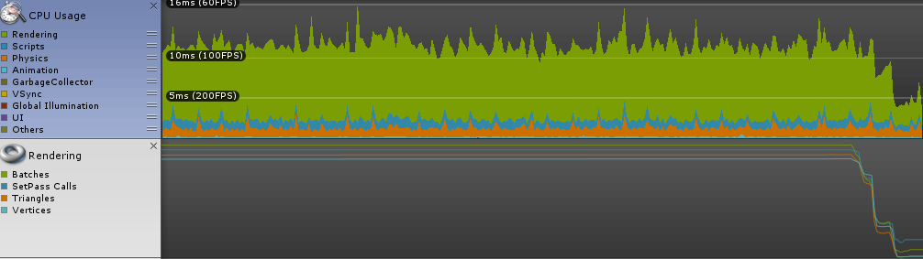

Figure 215 Regijus’ performance test after setting baked lights

Baked lights gave me even more fps and there were less batches than last time.

* 1. Optimize all textures depending on their parameters and measure graphical memory load;

I’ve optimized textures, setting all of their’s max sizes to 512, generating mip maps. I’ve included just a couple in figures just because the process looks pretty much the same for every texture.

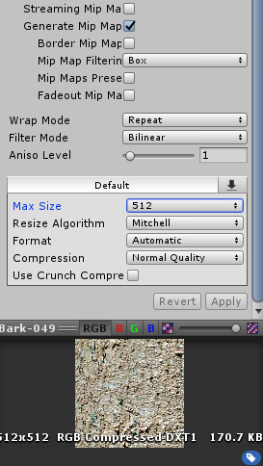

Figure 216 Regijus’ optimized texture 1

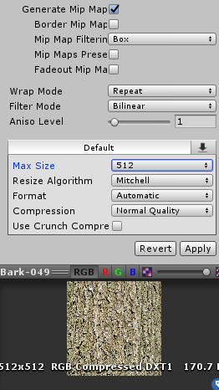

Figure 217 Regijus’ optimized texture 2

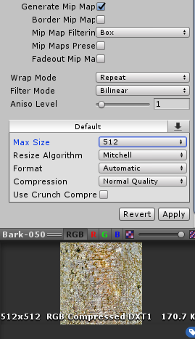

Figure 218 Regijus’ optimized texture 3

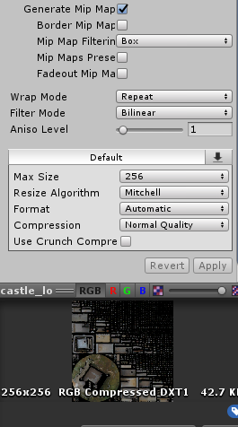

Figure 219 Regijus’ optimized texture 4

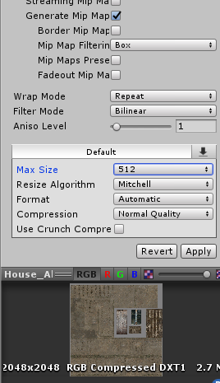

Figure 220 Regijus optimized texture 5

And so on…

Then I’ve benchmarked the game one more time.

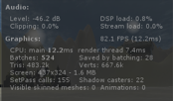

Figure 221 Regijus’ benchmark after optimizing textures

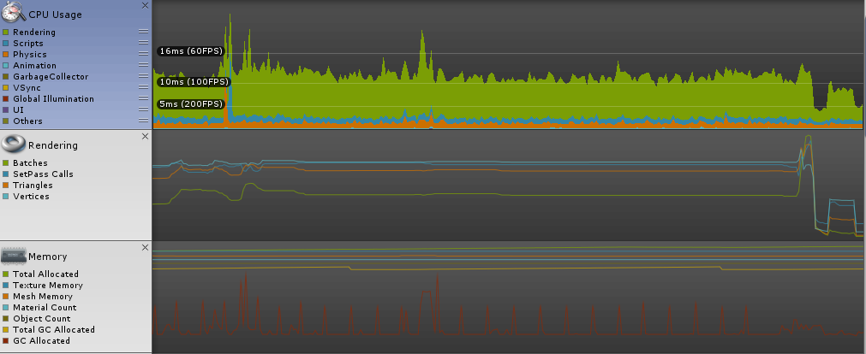

Figure 222 Regijus’ performance test after optimizing textures.

After optimizing textures, my game performance improved the most out of all these methods.

* 1. Try hard vs soft shadows, different quality settings and measure the performance;

First, I tried soft shadows.

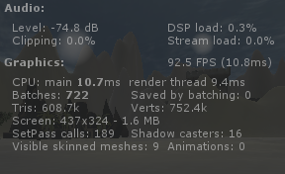

Figure 223 Regijus’ benchmark after applying soft shadows

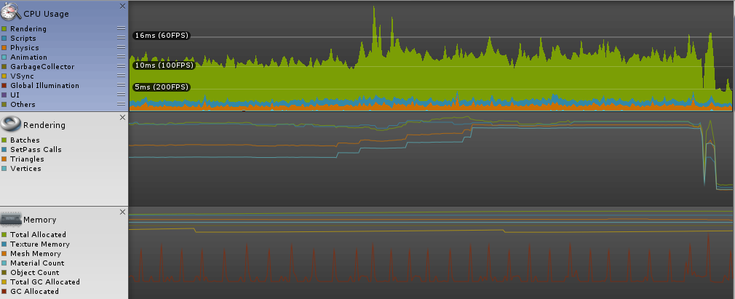

Figure 224 Regijus’ performance test after applying soft shadows

Then I’ve applied hard shadows to see which setting is better.

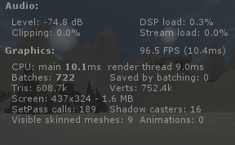

Figure 225 Regijus’ benchmark after applying hard shadows

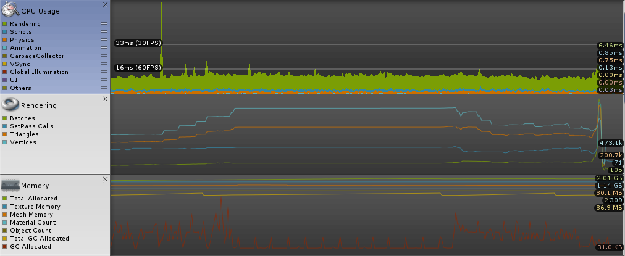

Figure 226 Regijus’ performance test after applying hard shadows

To conclude, hard shadows gave me better performance as these shadows are less detailed and they load faster.

### Jurgis Petrauskas

#### Terrain part

* 1. Create a terrain and color it using 5 or more materials of your own design.

I’ve formed mountains on the terrain and colored it using 5 sand texture materials.

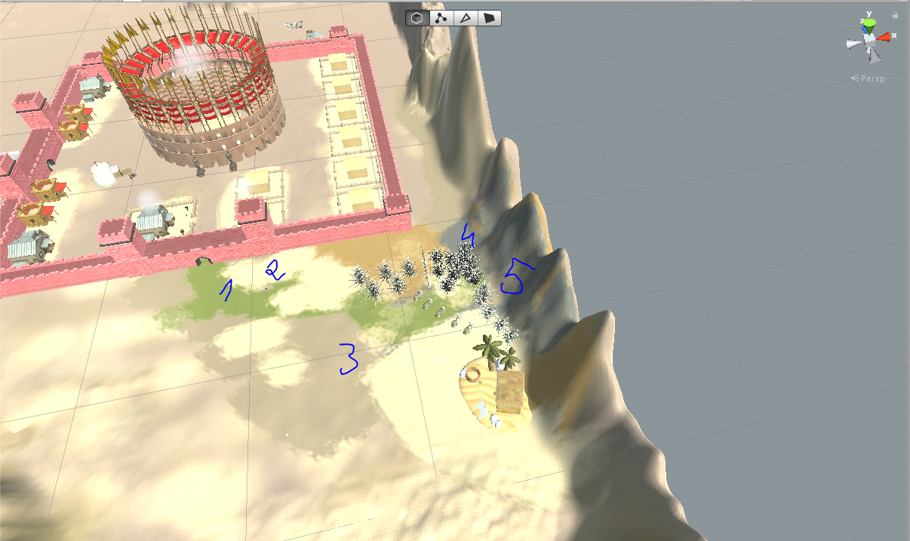

Figure 227 Terrain Layers applied to terrain

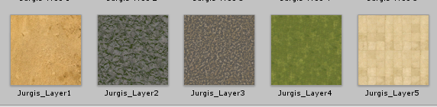

Figure 228 Custom terrain layers

* 1. Create 5 trees of your own construction and seed them using terrain tools.

I’ve created 5 unique trees and added different textures to them.

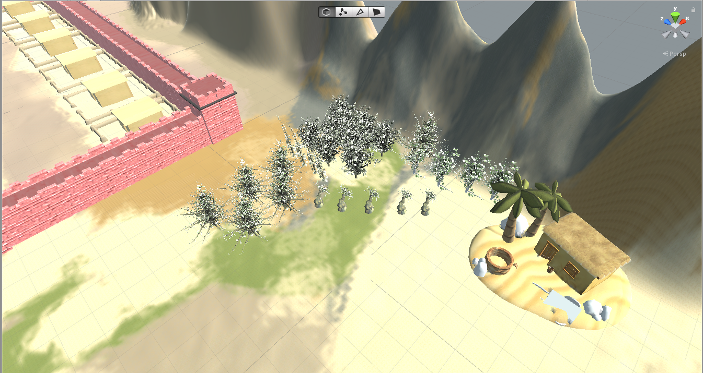

Figure 229 a park made of 5 different tress species

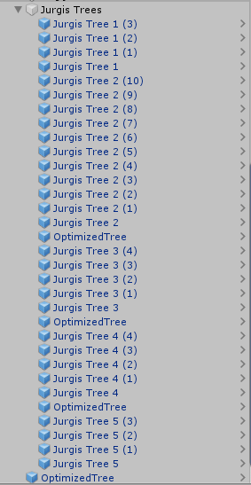

Figure 230 Trees hierarchy

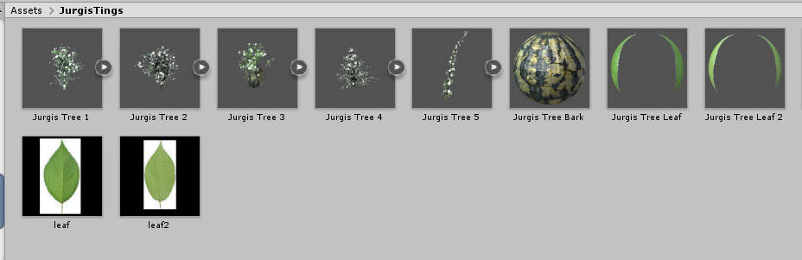

Figure 231 Tree materials and textures

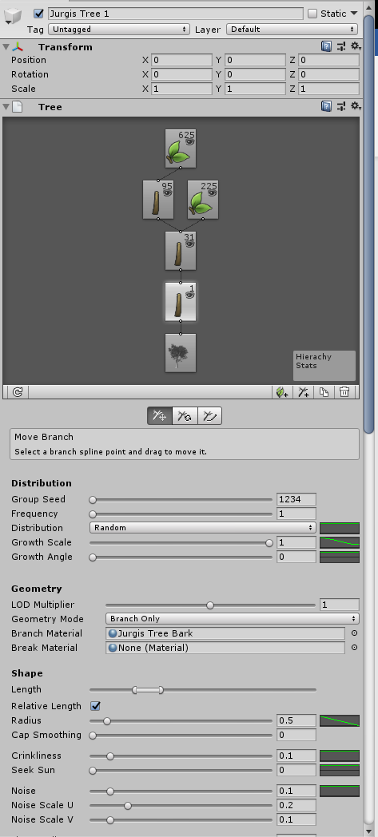

Figure 232 Jurgis Tree 1

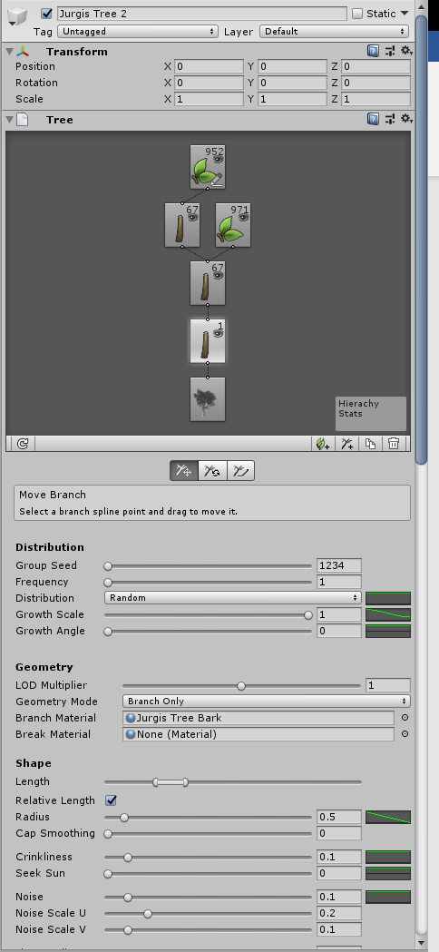

Figure 233 Jurgis Tree 2

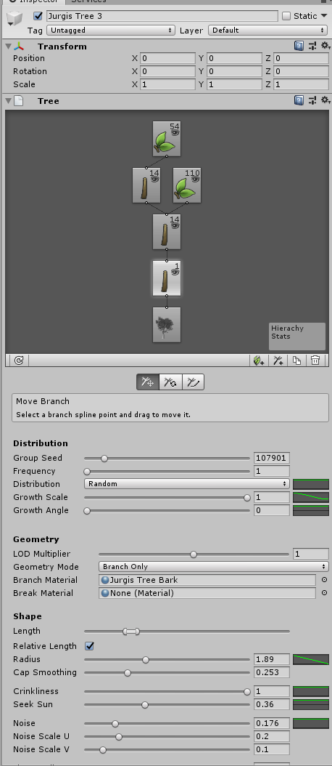

Figure 234 Jurgis Tree 3

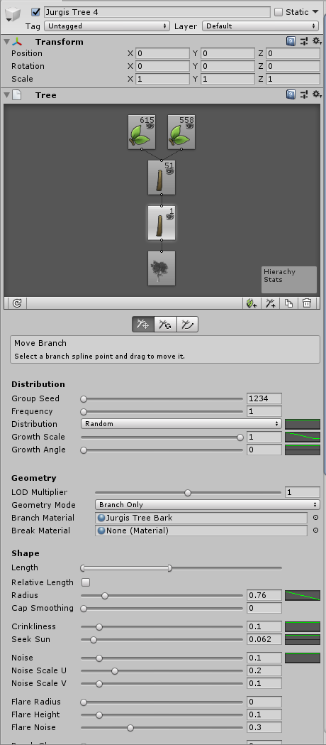

Figure 235 Jurgis Tree 4

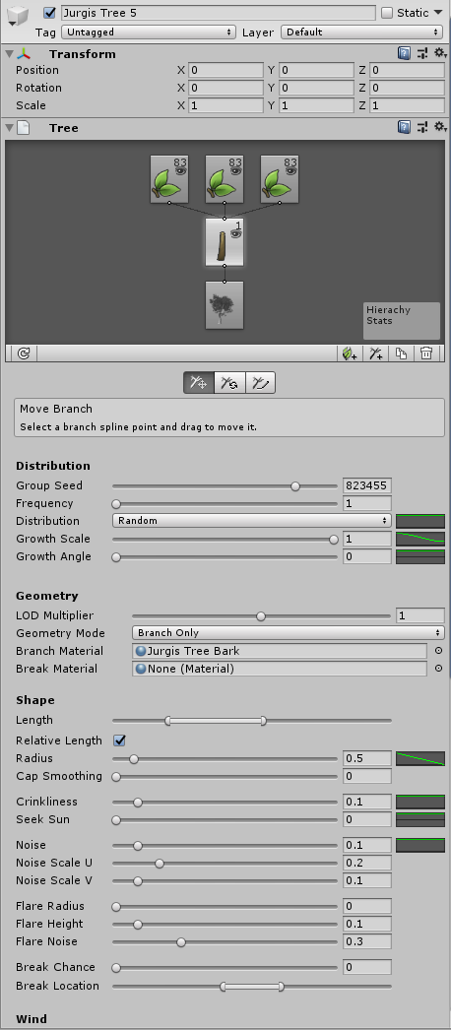

Figure 236 Jurgis Tree 5

#### Animation part

* 1. Import a unique model and assign it to a third person character controller



Figure 237 Model rigging



Figure 238 Model bone system



Figure 239 Model in game

* 1. Add and animate 5 objects to your game maps

I’ve animated 7 different objects, created the “wind effect” on trees and cactuses to fit with the game theme.



Figure 240 Regijus’ animations



Figure 241 Animation 1



Figure 242 Animation 2



Figure 243 Animation 3



Figure 244 Animation 4



Figure 245 Animation 5



Figure 246 Animation 6



Figure 247 Animation 7

#### Special Effects part

* 1. Create 5 unique (non-factory) particle effects (fire, portal, etc.)

I’ve created 5 different effects, played with parameters a lot to get what I wanted.



Figure 248 Regijus’ effects



Figure 249 Effect 1 – Portal



Figure 250 Effect 2 – Amber rain over the arena



Figure 251 Effect 3 – Small chimney smoke



Figure 252 Effect 4 - Huge dark smoke from stronghold



Figure 253 Effect 5 – Pyramid particle effect

* 1. Add a custom skybox

I’ve created 6-sided custom skybox.



Figure 254 Regijus’ skybox textures and materials



Figure 255 Regijus’ skybox

#### Physics part

* 1. Create 5 different physics materials and apply them in your project



Figure 256 Regijus’ physics materials



Figure 257 Physics material example



Figure 258 Another physics material example



Figure 259 Example of applied physics material on object

* 1. Assign an optimum collider based on the shape of the object for all 3D objects imported in the first laboratory work

I’ve assigned optimum colliders based on the shape of objects. Some colliders are box, some mesh and even capsule colliders.



Figure 260 Stronghold collider



Figure 261 Papaya trees colliders



Figure 262 Rocks colliders



Figure 263 Boxes colliders



Figure 264 Tyres and jerry cans colliders



Figure 265 City wall colliders



Figure 266 Simple house colliders



Figure 267 Anubis statues colliders



Figure 268 Store and cacti colliders



Figure 269 Beach house colliders

* 1. Add and animate 5 objects using PHYSICS, FORCE and TRIGGERS to your game maps (traps, falling objects, moving doors, etc)

I’ve animated more than 5 objects using different techniques.



Figure 270 Table dropdown animation

When a character enters the trigger (house entrance), the table falls down from the ceiling.



Figure 271 Barrell blow up animation

When P button is pressed, barrels “blow up” around.



Figure 272 Maze door dropdown animation

When a character enters the trigger, maze door falls down blocking the entrance.



Figure 273 Disappear animation

When a character touches the trigger, he can walk through it.



Figure 274 Move up animation

When a character touches the trigger, the block goes up, allowing player to pass the corridor.



Figure 275 Regijus’ physics scripts

#### Optimization part

First of all, I’ve benchmarked my game before doing any optimizations. Here are the results.



Figure 276 Regijus’ initial benchmark



Figure 277 Regijus’ performance test

After benchmarking the game, I’ve come to the conclusion that it runs around 60 fps. Batches can be seen in figures.

* 1. Set static flag to all immobile objects and measure batching performance;



Figure 278 Regijus’ benchmark after setting static



Figure 279 Regijus’ performance test after setting static

After these changes the fps has increased and there were less batches.

* 1. Try deferred vs forward rendering and measure performance for both;

First, I’ve tried deferred rendering.



Figure 280 Regijus’ benchmark after setting deferred rendering



Figure 281 Regijus’ performance test after setting deferred rendering

Then I‘ve tried forward rendering option.



Figure 282 Regijus’ benchmark after setting forward rendering



Figure 283 Regijus’ performance test after setting forward rendering

Forward rendering didn’t give me that much of a boost. I’ll stick to deferred because it does less batches and gives me more fps.

* 1. Bake a lightmap for your scene and measure performance;

First, I’ve changed lighting settings.



Figure 284 Regijus’ lighting settings

Then I‘ve changed lights‘ mode to baked. There‘s only one example in figures because it would all look pretty much the same anyway.



Figure 285 Regijus’ example of baked light



Figure 286 Regijus’ benchmark after setting baked lights



Figure 287 Regijus’ performance test after setting baked lights

Baked lights gave me even more fps and there were less batches than last time.

* 1. Optimize all textures depending on their parameters and measure graphical memory load;

I’ve optimized textures, setting all of their’s max sizes to 512, generating mip maps. I’ve included just a couple in figures just because the process looks pretty much the same for every texture.



Figure 288 Regijus’ optimized texture 1



Figure 289 Regijus’ optimized texture 2



Figure 290 Regijus’ optimized texture 3



Figure 291 Regijus’ optimized texture 4



Figure 292 Regijus optimized texture 5

And so on…

Then I’ve benchmarked the game one more time.



Figure 293 Regijus’ benchmark after optimizing textures



Figure 294 Regijus’ performance test after optimizing textures.

After optimizing textures, my game performance improved the most out of all these methods.

* 1. Try hard vs soft shadows, different quality settings and measure the performance;

First, I tried soft shadows.



Figure 295 Regijus’ benchmark after applying soft shadows



Figure 296 Regijus’ performance test after applying soft shadows

Then I’ve applied hard shadows to see which setting is better.



Figure 297 Regijus’ benchmark after applying hard shadows



Figure 298 Regijus’ performance test after applying hard shadows

To conclude, hard shadows gave me better performance as these shadows are less detailed and they load faster.

# Literature List

1. "TexturesCom_SoilSand0179_1_seamless_S.jpg"from https://www.textures.com/download/soilsand0179/48700?q=soilsand0179
2. "TexturesCom_Pavement_StoneGreen_1K_albedo.tif" from https://www.textures.com/download/pbr0182/133221
3. "TexturesCom_Rock_CliffDesert3_1K_albedo.tif" from https://www.textures.com/download/pbr0223/133279
4. "TexturesCom_MixedPavement2_3x3_1K_albedo.tif" from https://www.textures.com/download/3dscans0560/136854
5. "TexturesCom_FloorsRegular0235_1_seamless_S.jpg" from https://www.textures.com/download/floorsregular0235/26921
6. "TexturesCom_Cobblestone13_4x4_1K_albedo.tif" from https://www.textures.com/download/3dscans0574/136953
7. "TexturesCom_BrickOldMixedSize0012_1_seamless_S.jpg" from https://www.textures.com/download/brickoldmixedsize0012/45084
8. "TexturesCom_BrickMedievalBlocks0333_5_seamless_S.png" from https://www.textures.com/download/brickmedievalblocks0333/130751
9. "TexturesCom_BrickMedievalBlocks0330_11_seamless_S.jpg" from https://www.textures.com/download/brickmedievalblocks0330/116381
10. "TexturesCom_BrickMedievalBlocks0312_2_seamless_S.jpg" from https://www.textures.com/download/brickmedievalblocks0312/97394
11. "TexturesCom_BrickLargeBare0196_1_seamless_S.jpg" from https://www.textures.com/download/bricklargebare0196/53564
12. "desert environment" from http://devassets.com/assets/desert-environment/ by Sam Troth
13. https://medium.com/ironequal/unity-character-controller-vs-rigidbody-a1e243591483 script referenced in "MovementRB.cs" script
14. http://wiki.unity3d.com/index.php/RigidbodyFPSWalker script referenced in "MovementRB.cs" script
15. https://git.cs.nmt.edu/nhertz/game-jam-f2k16/blob/master/Assets/MouseLook.cs script modified
16. "TOZ Triplanar Shaders" from https://assetstore.unity.com/packages/vfx/shaders/toz-triplanar-shaders-32519 by "Aubergine"
17. "Yughues Free Concrete Materials" from https://assetstore.unity.com/packages/2d/textures-materials/concrete/yughues-free-concrete-materials-12951 by "Nobiax / Yughues"
18. "Desert Sandbox LITE" from https://assetstore.unity.com/packages/3d/environments/fantasy/desert-sandbox-lite-25935 by "Aquarius Max"
19. "POLYDesert" from https://assetstore.unity.com/packages/3d/environments/landscapes/polydesert-107196 by "Runemark Studio"
20. "LowPoly Environment Pack" from https://assetstore.unity.com/packages/3d/environments/landscapes/lowpoly-environment-pack-99479 by "Korveen"
21. "Sandstone Wall Construction Kit" from https://assetstore.unity.com/packages/3d/props/exterior/sandstone-wall-construction-kit-19235 by "Unity Technologies"
22. "Low poly styled rocks" from https://assetstore.unity.com/packages/3d/props/exterior/low-poly-styled-rocks-43486 by "Daniel Robnik"
23. "Long note One", "Ossuary 6 - Air", "Ready Aim Fire" Kevin MacLeod (incompetech.com) Licensed under Creative Commons: By Attribution 3.0 http://creativecommons.org/licenses/by/3.0/
24. “Castle Villalonso” from https://sketchfab.com/3d-models/castle-villalonso-zamora-spain-5dbe4dc71d8841339e5e602cdcc3f1fc
25. “Axe Low Poly” from https://sketchfab.com/3d-models/axe-low-poly-05703932eb2c45c0918d4f91c875d064
26. “Bucket” from https://sketchfab.com/3d-models/bucket-a63bd9fb2a4649ffaed97a8798647909
27. “Tent” from https://sketchfab.com/3d-models/tent-af33dfc172954f86a09fc30e7af6ffd7
28. “Campfire” from https://sketchfab.com/3d-models/campfire-1ef99d8d5bda4995871bcf39ef4bcb1d
29. “Barrell” from https://sketchfab.com/3d-models/barrel-805be8c20e1f481893bd796d38ab8dc7
30. “Ladder” from https://sketchfab.com/3d-models/ladder-adf229c426194740ab0ec9cdb00262b4
31. “Keep Out Signpost” from https://sketchfab.com/3d-models/keep-out-signpost-7598a84aebcf47a684dd83476550d5cd
32. “Anubis statue” from https://sketchfab.com/3d-models/anubis-statue-b68da033e5da46408a1b58ccdc973435
33. “Stadium Applause” sound from http://soundbible.com/444-Stadium-Applause.html
34. “Wind” sound from http://soundbible.com/1810-Wind.html
35. ”Castle Walls” from https://sketchfab.com/3d-models/castle-walls-e9aa5d571bc64e1c90cd511cca7f98f9

# ANNEX

All source code

**MovementRB:**

using System.Collections;

using System.Collections.Generic;

using UnityEngine;

public class MovementRB : MonoBehaviour

{

public float speed = 10.0f;

public float gravity = 10.0f;

public float maxVelocityChange = 10.0f;

public bool canJump = true;

public float jumpHeight = 2.0f;

private bool _isGrounded = false;

public float GroundDistance = 0.2f;

private Rigidbody rb;

private CapsuleCollider col;

public float distToGround;

public Transform Transform;

public float airdrag = 0.2f;

public float normaldrag;

public float sprintSpeedMult = 1.4f;

private float dToGround;

void Awake()

{

rb = GetComponentInChildren<Rigidbody>();

col = GetComponentInChildren<CapsuleCollider>();

dToGround = col.height / 2;

rb.freezeRotation = true;

rb.useGravity = true;

normaldrag = rb.drag;

}

void FixedUpdate()

{

_isGrounded = IsGrounded();

if (_isGrounded)

{

//print("grounded");

// Calculate how fast we should be moving

Vector3 targetVelocity = new Vector3(Input.GetAxis("Horizontal"), 0, Input.GetAxis("Vertical"));

targetVelocity = transform.TransformDirection(targetVelocity);

if (Input.GetKey(KeyCode.LeftShift))

targetVelocity *= speed*sprintSpeedMult;

else

targetVelocity *= speed;

// Apply a force that attempts to reach our target velocity

Vector3 velocity = rb.velocity;

Vector3 velocityChange = (targetVelocity - velocity);

velocityChange.x = Mathf.Clamp(velocityChange.x, -maxVelocityChange, maxVelocityChange);

velocityChange.z = Mathf.Clamp(velocityChange.z, -maxVelocityChange, maxVelocityChange);

velocityChange.y = 0;

rb.AddForce(velocityChange, ForceMode.VelocityChange);

// Jump

if (_isGrounded && Input.GetButton("Jump"))

{

rb.velocity = new Vector3(velocity.x, CalculateJumpVerticalSpeed(), velocity.z);

_isGrounded = false;

rb.drag = airdrag;

}

}

// We apply gravity manually for more tuning control

rb.AddForce(new Vector3(0, -gravity * rb.mass * 2, 0));

_isGrounded = false;

}

float CalculateJumpVerticalSpeed()

{

// From the jump height and gravity we deduce the upwards speed

// for the character to reach at the apex.

return Mathf.Sqrt(2 * jumpHeight * gravity);

}

bool IsGrounded()

{

//should do multiple raycasts so you dont get stuck on holes or a collision check

if(Physics.Raycast(transform.position, -Vector3.up, dToGround + 0.1f))

{

//print("grounded");

return true;

}

else

{

//print("not grounded");

//print(dToGround);

return false;

}

}

}

**OnTrigger_zone_music:**

using System.Collections;

using System.Collections.Generic;

using UnityEngine;

public class OnTrigger_zone_music : MonoBehaviour

{

public AudioClip music;

public AudioSource audio_player;

public float volume_mult = 1;

private float old_volume;

// Start is called before the first frame update

void Start()

{

//audio_player = GameObject.Find("Background_music_player").GetComponent<AudioSource>();

// need to check if the labyrinth has been beaten before

}

// Update is called once per frame

void OnTriggerEnter(Collider other)

{

if(other.tag == "Player")

{

Debug.Log("player has entered the labyrinth");

audio_player.Stop();

audio_player.clip = music;

old_volume = audio_player.volume;

audio_player.volume *= volume_mult;

audio_player.Play();

}

}

void OnTriggerExit(Collider other)

{

if (other.tag == "Player")

{

audio_player.volume = old_volume;

Debug.Log("player has left the labyrinth");

audio_player.Stop();

}

}

}

**Moving_platform_up:**

using System.Collections;

using System.Collections.Generic;

using UnityEngine;

public class Moving_platform_up : MonoBehaviour

{

public float speed = 5;

public float distance = 5;

public float stop_time = 2;

public bool one_way = false;

private float elapsed_time;

private float distance_traveled;

private bool moving = false;

private float location_start;

private float location_end;

private bool up = true;

// Start is called before the first frame update

void Start()

{

elapsed_time = 0;

distance_traveled = 0;

location_start = transform.position.y;

location_end = location_start + distance;

}

// Update is called once per frame

void Update()

{

float time = Time.deltaTime;

if(moving)

if(distance_traveled >= distance)

{

distance_traveled = 0;

moving = false;

speed *= -1;

if(up)

{

transform.position = new Vector3(transform.position.x, location_end, transform.position.z);

up = false;

}

else

{

transform.position = new Vector3(transform.position.x, location_start, transform.position.z);

up = true;

}

if (one_way)

//gameObject.SetActive(false);

this.enabled = false;

}

else

{

transform.Translate(Vector3.up * time * speed);

distance_traveled += time * Mathf.Abs(speed);

}

else

{

if (elapsed_time >= stop_time)

{

elapsed_time = 0;

moving = true;

}

else

elapsed_time += time;

}

}

}

**Labyrinth_finish_trigger:**

using System.Collections;

using System.Collections.Generic;

using UnityEngine;

public class Labyrinth_finish_trigger : MonoBehaviour

{

bool cleared;

public GameObject platform;

Collider col;

// Start is called before the first frame update

void Start()

{

col = GetComponent<Collider>();

cleared = false; //load from profile on build

}

void OnTriggerEnter(Collider other)

{

Debug.Log("entered");

if (other.tag == "Player")

{

Debug.Log("is player");

cleared = true;

platform.SetActive(true);

}

}

}

**BlowBarrels.cs:**

using System.Collections;

using System.Collections.Generic;

using UnityEngine;

public class BlowBarrels : MonoBehaviour

{

void Update()

{

if (Input.GetKeyDown(KeyCode.P))

{

transform.position += Vector3.forward;

}

}

}

**DropDown.cs:**

using System.Collections;

using System.Collections.Generic;

using UnityEngine;

public class DropDown : MonoBehaviour

{

public Rigidbody rb;

void Start() {

rb = GetComponent<Rigidbody>();

}

void OnTriggerEnter(Collider other) {

if (rb.useGravity == false) {

rb.useGravity = true;

}

}

}

**DropTableDown.cs:**

using System.Collections;

using System.Collections.Generic;

using UnityEngine;

public class DropTableDown : MonoBehaviour

{

public Rigidbody table;

void Start() {

table = GetComponent<Rigidbody>();

}

void OnTriggerEnter(Collider collider) {

table.useGravity = true;

table.mass = 25;

}

}

**WallDisappear.cs:**

using System.Collections;

using System.Collections.Generic;

using UnityEngine;

public class WallDisappear : MonoBehaviour

{

public void OnTriggerEnter(Collider other)

{

if (other.gameObject != null) {

Destroy(other.gameObject, 3f);

}

}

}

**MoveUp.cs:**

using System.Collections;

using System.Collections.Generic;

using UnityEngine;

public class MoveUp : MonoBehaviour

{

public Rigidbody rb;

void Start()

{

rb = GetComponent<Rigidbody>();

}

void OnTriggerEnter(Collider collider)

{

transform.position += Vector3.up;

}

}